[1]

Stream Depth Sensor(December 2015)

Alejandro Johnson-Eusebio, *Student, UAA*, Joshua R. Shafer, *Student*, UAA

*Abstract*— An increased concern in the environment’s health in different ecosystems has sparked a need for instruments that can measure different aspects of each system. This stream depth sensor developed by the National Oceanic and Atmospheric Association (NOAA) uses an acoustic sensor to measure the water level in streams and rivers. The data this device collects is important in monitoring fish ecosystems, wildlife behavior, and predicting floods among other uses which require water level measurements. The purpose of our project is to redesign the current model of the stream depth sensor in order to make the instrument more stable and efficient compared to the original design. Some known issues with the current stream depth sensor are 3.3-5V logic level mismatch, extra components not being used, and not enough power is being transmitted to all components of the overall circuit. The scope of this project is to first address any power issues by making sure the correct voltage and amperage is applied to each component with the correct logic levels. Next would be to remove excess parts or add any that may be needed in order to ensure a stable and smooth system. While working on the revision of the circuit, at the same time, we are becoming familiar with the mill and the milling process in order to make Printed Circuit Boards (PCB).  The goal is to be able to have a PCB with all the same functions as the original, but more efficient and with surface mounted components.

# INTRODUCTION

T

HE stream depth sensor developed by National Oceanic and Atmospheric Association (NOAA) uses an acoustic sensor and an Arduino Pro Mini, which is a microcontroller for the circuit board, to measure the water level in streams and rivers. Once the device gathers all the data, the information is sent to an Iridium Modem Transceiver which is a device that transmits as well as receives information via wireless link. The data obtained from the device then may be analyzed to calculate the water level of a stream, river, or other body of water by being mounted above it such as on a bridge. The depth sensor uses a battery as the power source as well as a solar panel which supplies power to both the battery and the instrument. This project’s purpose is to redesign the current model in order to make it more stable and efficient to the original, while at the same time becoming familiar with the mill and the milling process in order to make Printed Circuit Boards (PCB).

While it is working, it has several known issues and improvements that NOAA would like addressed.  This project will focus on the first five items on the list.  Those items are:

1. Modify the printed circuit board to use all surface mounted components for machine manufacturer

The issue is that the current board is using through-hole technology for the circuit board and NOAA would like a surface mounted design. In learning how to use a printed circuit board mill and other software related to creating a printed circuit board the circuit design will have to be changed in order for surface mounted components to fit properly.

1. Improve solar charging scheme

Currently the solar panel is connected to the battery and the circuit board which is not the most efficient configuration. A solution is to look for commonly used solar panel configurations that are more efficient than the current design as well as look for higher quality components.

1. Confirm iridium power supply is sufficient

The problem is that the circuit of the stream depth sensor is not transmitting sufficient power for normal function. A solution to this is to review the design and determine if the power of the iridium modem is sufficient as well as if any voltage regulators need to be considered.

1. Meet tighter specifications for newer 9603 iridium modem

NOAA would like to upgrade to a newer model of the iridium modem, but are not certain if the current circuit is compatible to upgrade. Research will have to be done on the 9603 model in order to determine proper functionality in the circuit.

1. Revise RS 232 logic levels to 3.3V.

The circuit board is not all at the same logic voltage level and may cause a problem within the circuitry of the depth sensor. To resolve this issue, a revision of the schematic will be done in order to determine if proper levels are being used and if not, then to regulate the voltages accordingly.

# Scope

The scope of this project is to first address any power issues by making sure the correct voltage and amperage is applied to each part.  Next would be to remove excess parts or add any that may be needed.  The second part of this project is to become familiar with the PCB milling process and design. The end result of this project is to have a streamlined PCB with all the same functionality as the original for around the same price that also has all surface mounted components. This project also had some constraints. One of them was that NOAA has had good luck with the current enclosure and wanted any new design work to fit in the existing space. The final design also had to remain mobile with low voltages that could be provided with a battery and a solar panel to charge it. These sensors also have to be able withstand the cold temperatures and harsh weather of the arctic.

# Current Work: Sensor

For this schematic, as seen in Figure 1, some of the voltage levels are wrong or could be done better.  The design of the schematic also has supernumerary resistors and perhaps some other extra parts, depending on what NOAA wants in the design. It presently also has a mechanical reset switch and an 8 through-hole pin-out attached to the Arduino. These parts are unnecessary and as such, have been left off either partially or entirely from the actual production model. The reset switch was deemed obsolete since the device can be reset remotely using software. The 8 through-hole pin-out is on the circuit board, however, it doesn’t have the resistors in the connections.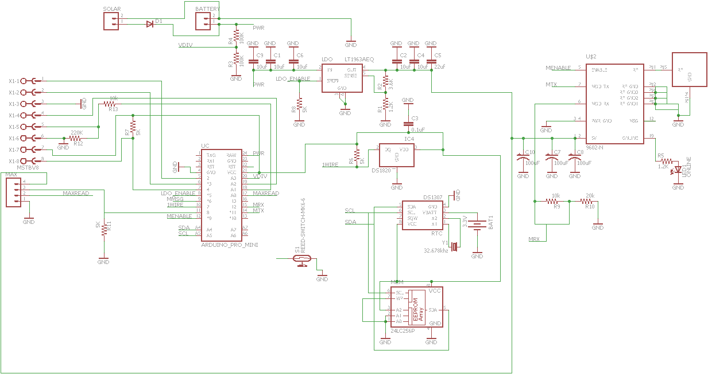

Fig 1: Stream Depth Sensor Schematic

The existing schematic’s main components are a 6V battery, a 9V solar panel, an Arduino Pro Mini 5V (Arduino Pro Mini), a voltage regulator, a distance sensor, and a satellite 9602 iridium modem.  The Arduino is used to run the circuit.  It can take an input voltage of up to 12V into the “raw” I/O pin.  Voltage applied to the raw pin on the Arduino is passed through the existing onboard voltage regulator.  This turns the VCC I/O pin into a 5V regulated output.  This output is then used to power all of the elements on the circuit except the modem and the distance sensor.  The only problem is that by doing this, the current draw may be too high. The iridium modem needs an input voltage and current of 5V and 1.5 amps respectively (Iridium 9602).  It is used to relay the data back to NOAA via satellite. The current setup using the voltage regulator (LT1963A) should be sufficient to supply the correct voltage for the modem and the distance sensor.  This distance sensor uses sound waves to measure the depth of a body of water.  This circuit also has a non-volatile memory chip and a clock.  These are used to store the data and the clock is used to tell the circuit when to do a task.  The battery is used to power everything on the circuit, and the solar panel recharges the battery. All these components can be seen the PCB in Fig 2. 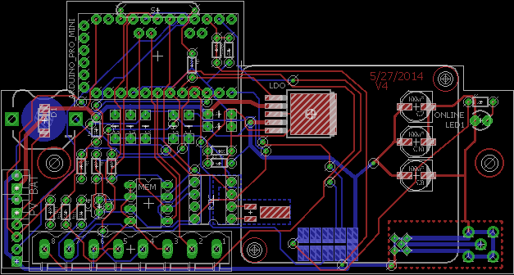

Fig 2: Stream Depth Sensor Circuit Board

1. Charging Scheme

The 9V solar panel is connected to the 6V battery through a diode in order to prevent reverse currents. Other options were considered using transistors and pull-up resistors in order to increase the current and/or the voltage, but as this is a low voltage circuit, the current model will be fine.

1. Iridium Power Supply

The input to the iridium 9602 modem was connected to an oscilloscope while the modem was sending in order to measure the voltage levels. As seen in Fig. 3, the voltage spikes a little bit when it first turns on, but then it calms down right at the 5V level, where it should be. This spike is likely due to an electrostatic discharge when the compenent is first turned on. This turn-on voltage spike only shot up to 5.19V, which is within the tolerance of the modem’s 5+/-0.5V.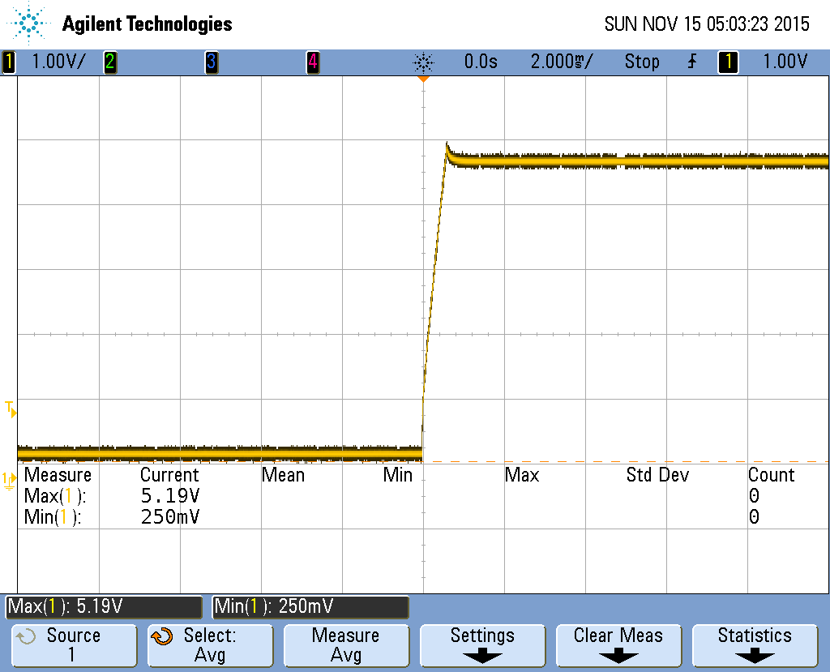

Fig 3: Iridium Modem Input

The newer iridum 9603 modem also has the same voltage level requirements and is smaller. Therefore, if NOAA, did decide to upgrade to the newer model, the voltage levels and physical size are both withing parameters.

1. Voltage Logic Levels

In the current version of this circuit, all of the components are run at 5V. With this voltage level as opposed to 3.3V, the acoustic sensor is stronger and more accurate. Therefore, the circuit should uniformly remain at 5V with one exception. The Arduino output signals are 5V, but the modem’s input signals require 3.3V. The modem can operate at the higher logic level, but it isn’t recommended as it is likely to damage it or cause it to fail in the future. In order to remedy this problem, a voltage divider with two resistors was implemented to cut the voltage down to the required level of 3.3V. This voltage divider was already in the schematic, but it was short circuited and the resistors were not populated on the PCB. It is now correctly represented in the schematic.

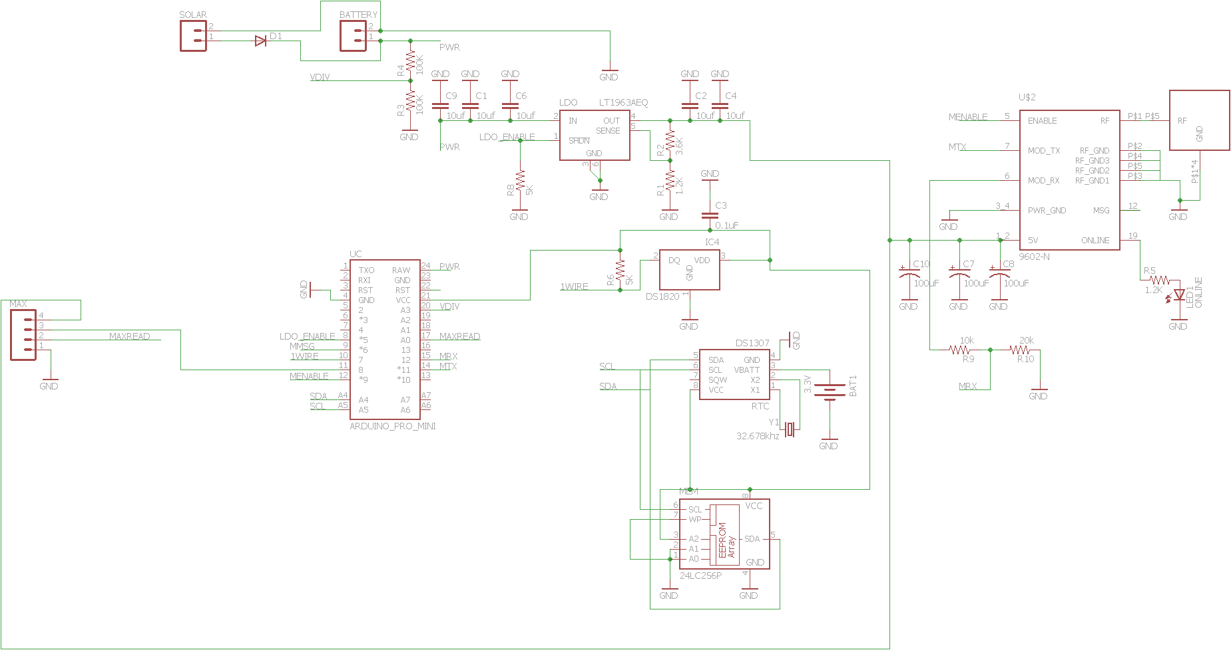

Fig. 3: Modified Schematic

The final modified circuit can be seen in Fig. 3. Some of the parts could be utilized the future, especially the 8 through-hole pin-out as this adds extra easy connections to the Arduino, but in the current design, they are not needed. Once the schematic was finalized, a new PCB was generated, as seen in Fig. 4. Larger versions of the schematic and PCB can be seen in the appendix.

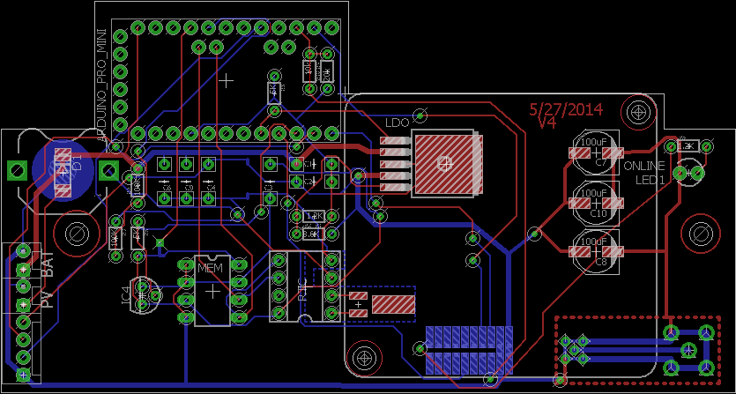

Fig 4 Modified PCB

# Future Work: Sensor

The next steps in the project would be to reduce the amount of capacitors in the circuit. The current design has quite a few that could be replaced with just one big one. Also, while the voltage levels can be measure directly and easily, the currents cannot. In order to measure the current, and ohmmeter needs to be placed in series with the component in question. This would require breaking a connection in order to insert the ohmmeter. Since the only device available for testing was on loan from NOAA, the circuit board was not broken in order to measure the amperage. Another feature that could be added would be an integrated Arduino.

# Current Work: Mill

In order to familiarize ourselves with the mill and the milling process, we looked over the tutorials provided with the mill, as well as the website Sparkfun.com in order to use the mill and the schematic program EAGLE (CadSoft).  We designed a 4th order lowpass butterworth filter using EAGLE (Figure 5), then routed it onto a board (Figure 6), and finally, milled the actual board as seen in Figures 7. The theoretical data was calculated in Matlab to make sure that the filter performs accordingly.

After familiarizing ourselves with all the software and hardware, a surface mounted PCB was drafted up. This PCB utilized surface mount technology as opposed to the current through-hole design. In addition to the surface mounted PCB, a tutorial was also drafted up in order to help other students and teachers alike use the EAGLE software and the PCB mill in the future. 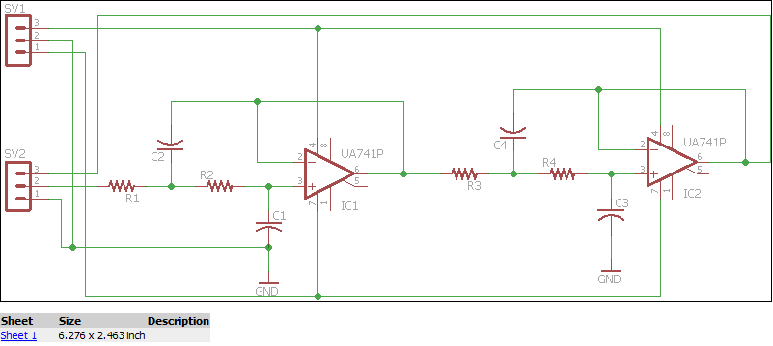Fig 5: 4th Order Butterworth Lowpass Filter Schematic

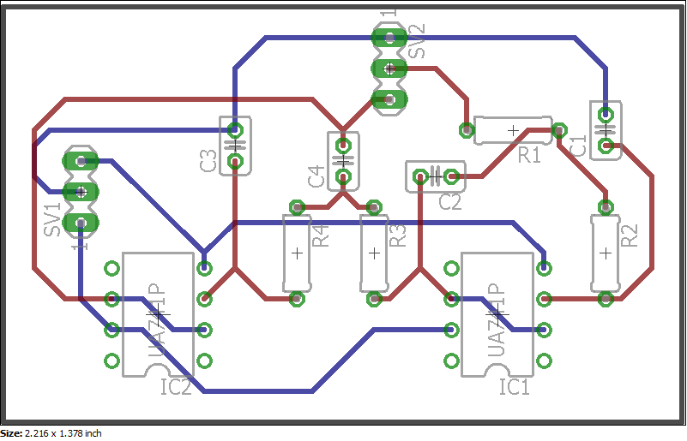

Fig 6: Printed Circuit Board Design

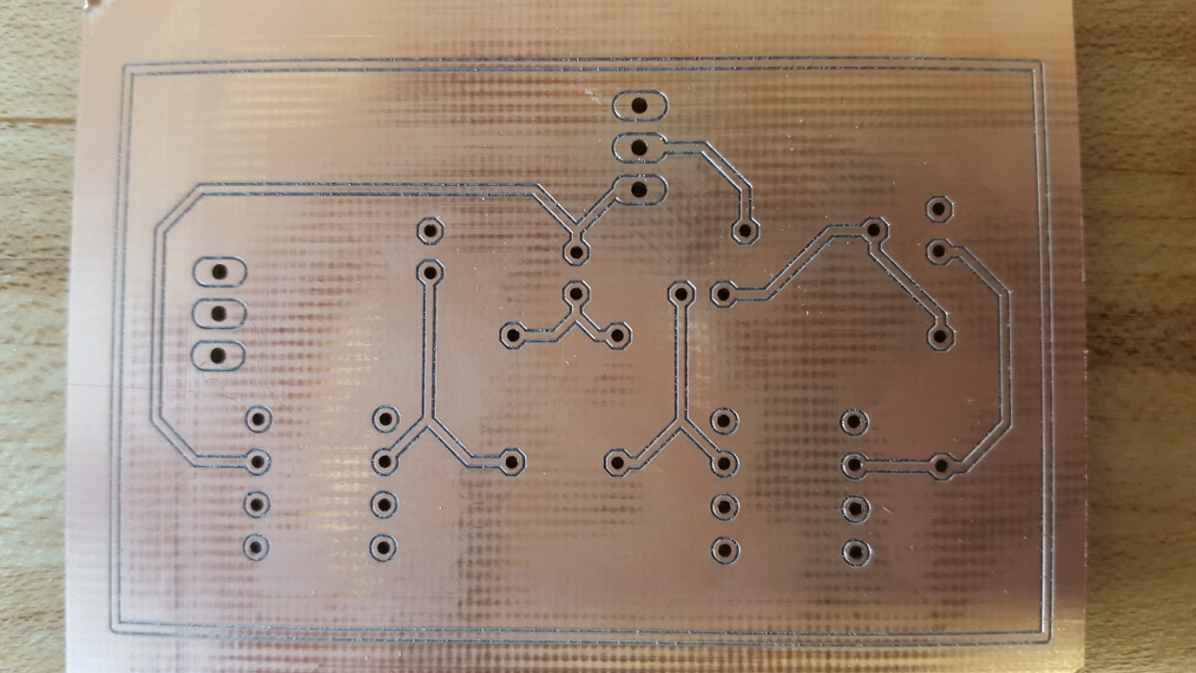

Fig 7: Butterworth Filter Milled Board

# Future Work: Mill

The next order of business is to take the surface mounted PCB that was drafted up as seen in Fig. 8 and change the components to make it fit in the current enclosure. Since the size of the board changed, the screw holes will also need to be adjust accordingly. After the board in finalized, it will need to be milled and have the components soldered on. Surface mounted components are usually affixed by applying a special solder material and baking it until the solder melts attaching the components. At present, we don’t have access to an oven, but acquiring one could allow us to finish the PCB. Or the components could potentially be soldered on by hand.

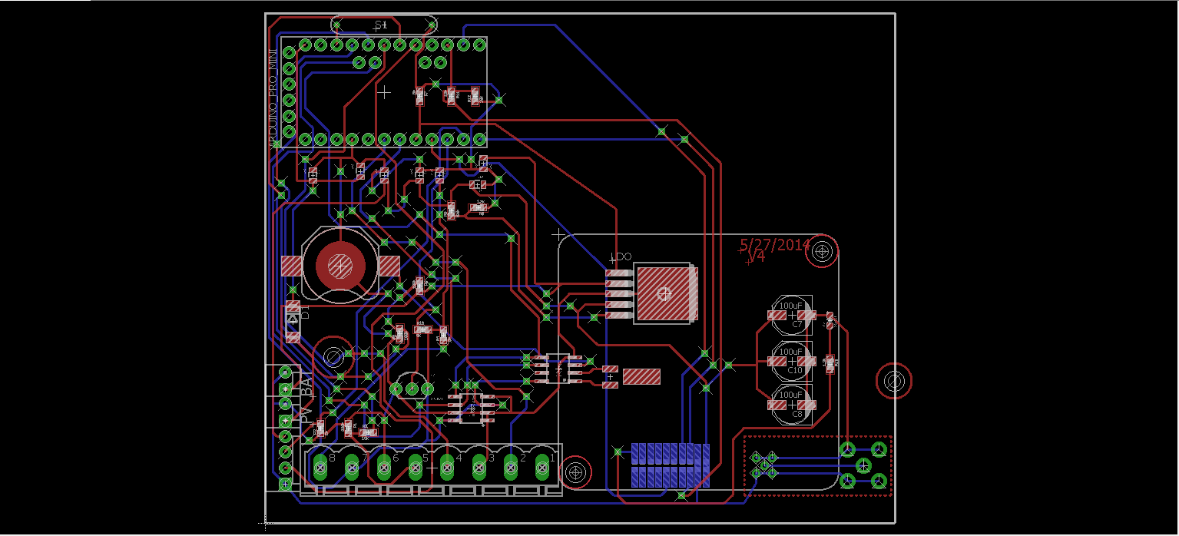

Fig 8: Surface Mounted PCB

# Conclusion

The stream depth sensor developed by NOAA uses an acoustic sensor with temperature compensations to measure the water level in streams and rivers.  This data is important in monitoring fish ecosystems and predicting floods, among other things.  By accomplishing this project’s purpose by redesigning the current model in order to make it work more efficient when compared to the original, it will be more stable.  This project also made us more familiar with the mill and the milling process in order to make PCB’s which will help us in the future as electrical engineers. The printed circuit board was successfully modified to utilized surface mounted technology. The charging scheme was analyzed and its performance was judged to be satisfactory for this type of circuitry. The iridium modem was probed to ensure its functionality, which was also within the required specifications. Finally, the RS 232 logic levels were inspected and fixed to be their correct voltage amounts. Overall, this project delivered what was expected from the client, NOAA. The secondary client, the University of Alaska Anchorage, received a comprehensive tutorial for running the mill as their deliverable. It will be bound and put with the mill in order to help students and students alike. This tutorial is included as an appendix. In the future, a surface mounted design could be finalized, printed, soldered, and tested. During this testing process, an ohmmeter could then more easily be attached in order to measure the currents. While theoretically, the amperage is correct, the experimental values may differ. If the current is found to be lacking, more design changes may need to be implemented.

# Appendix

## Comprehensive Parts List with Costs

## 

## Original Circuit

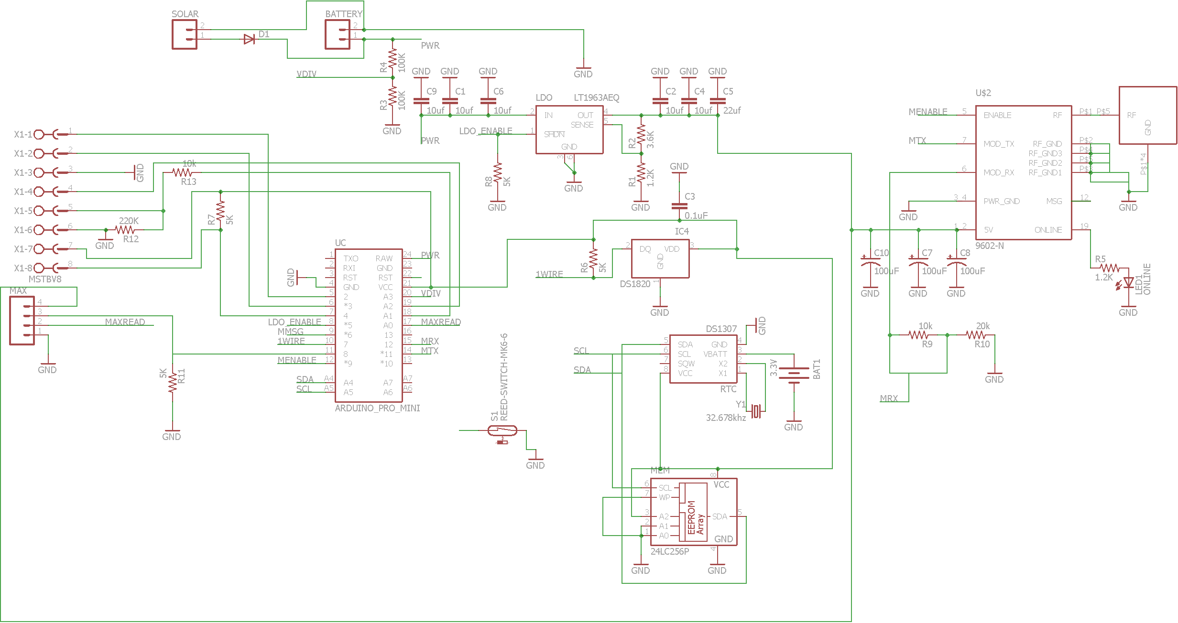

## Modified Circuit

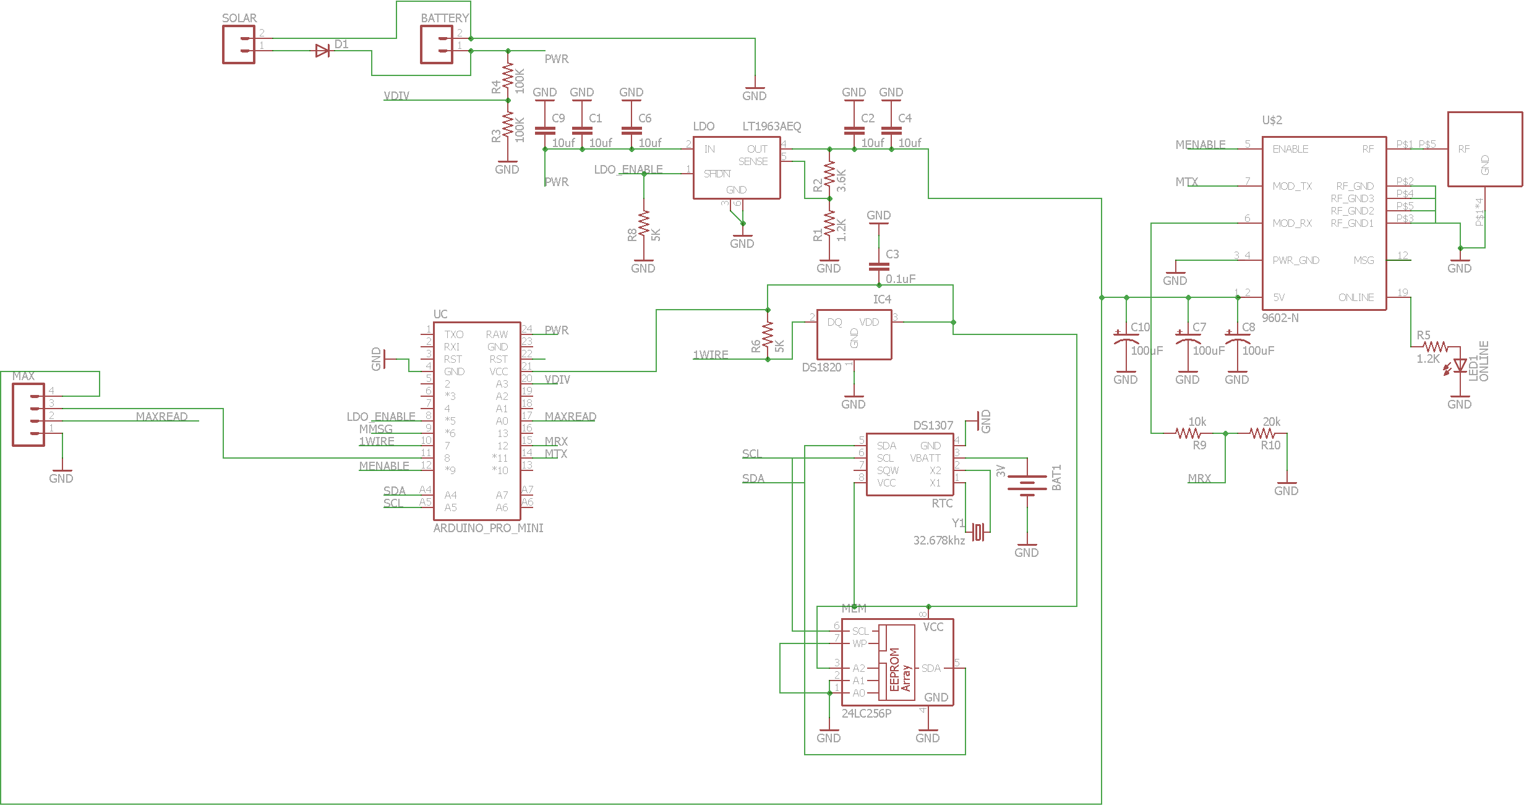

## Original Printed Circuit Board

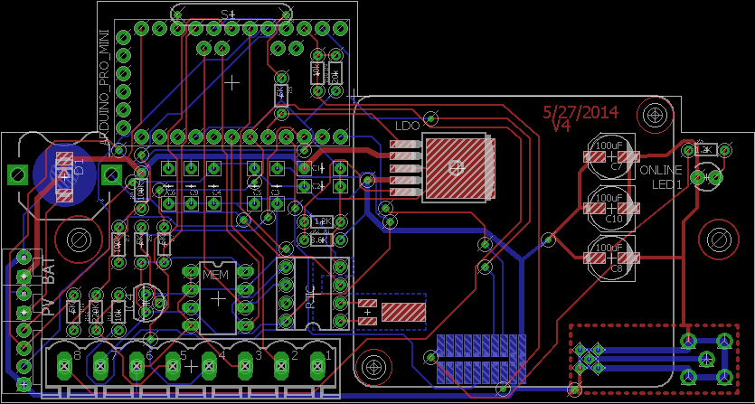

## Modified Printed Circuit Board



## Surface Mounted Printed Circuit Board

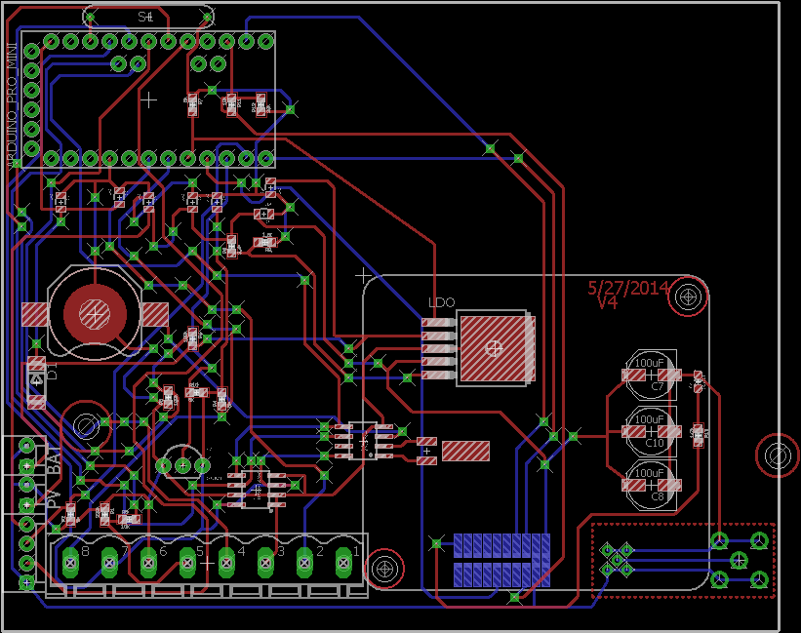

## Tutorial

Topics Covered:

* Creating a Schematic in Eagle
* Creating a Board Layout in Eagle
* Error Checking in Eagle
* Gerber File Generation in Eagle
* Circuit Pro Startup
* Importing Gerber Files in Circuit Pro
* Tool Calculations in Circuit Pro
* Milling Board in Circuit Pro

Eagle

The tutorial will assume the use of the CadSoft Eagle software for Printed Circuit Board (PCB) design, but there are other programs that may be used for PCB design.

To begin, open Eagle to the start window (See Figure Below).

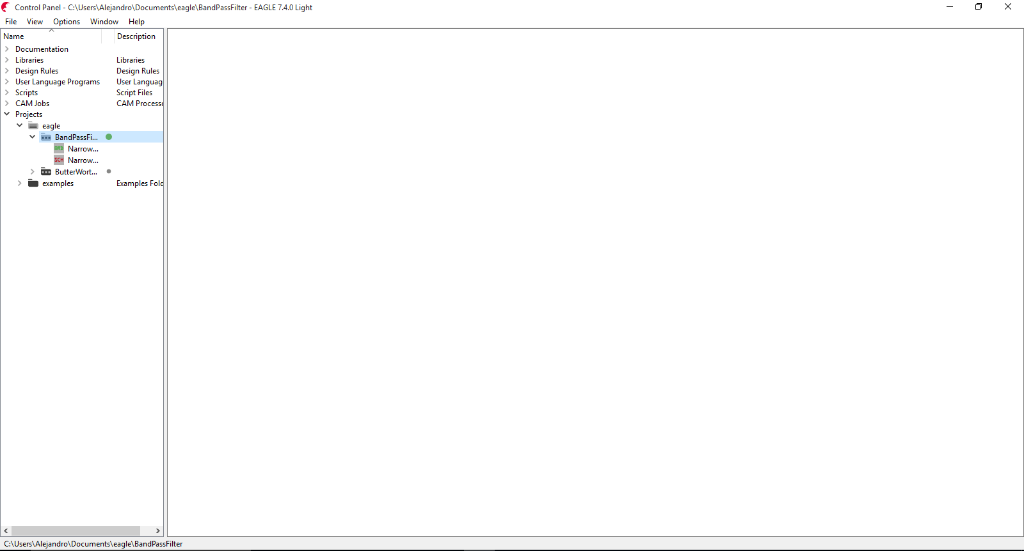

Fig 9: CadSoft Eagle Program Start Menu

In the start window click on File >> New >> Schematic to start a new schematic. Once the schematic window is shown then the first step is to add components by going to Edit >> Add… as shown in the figure below.

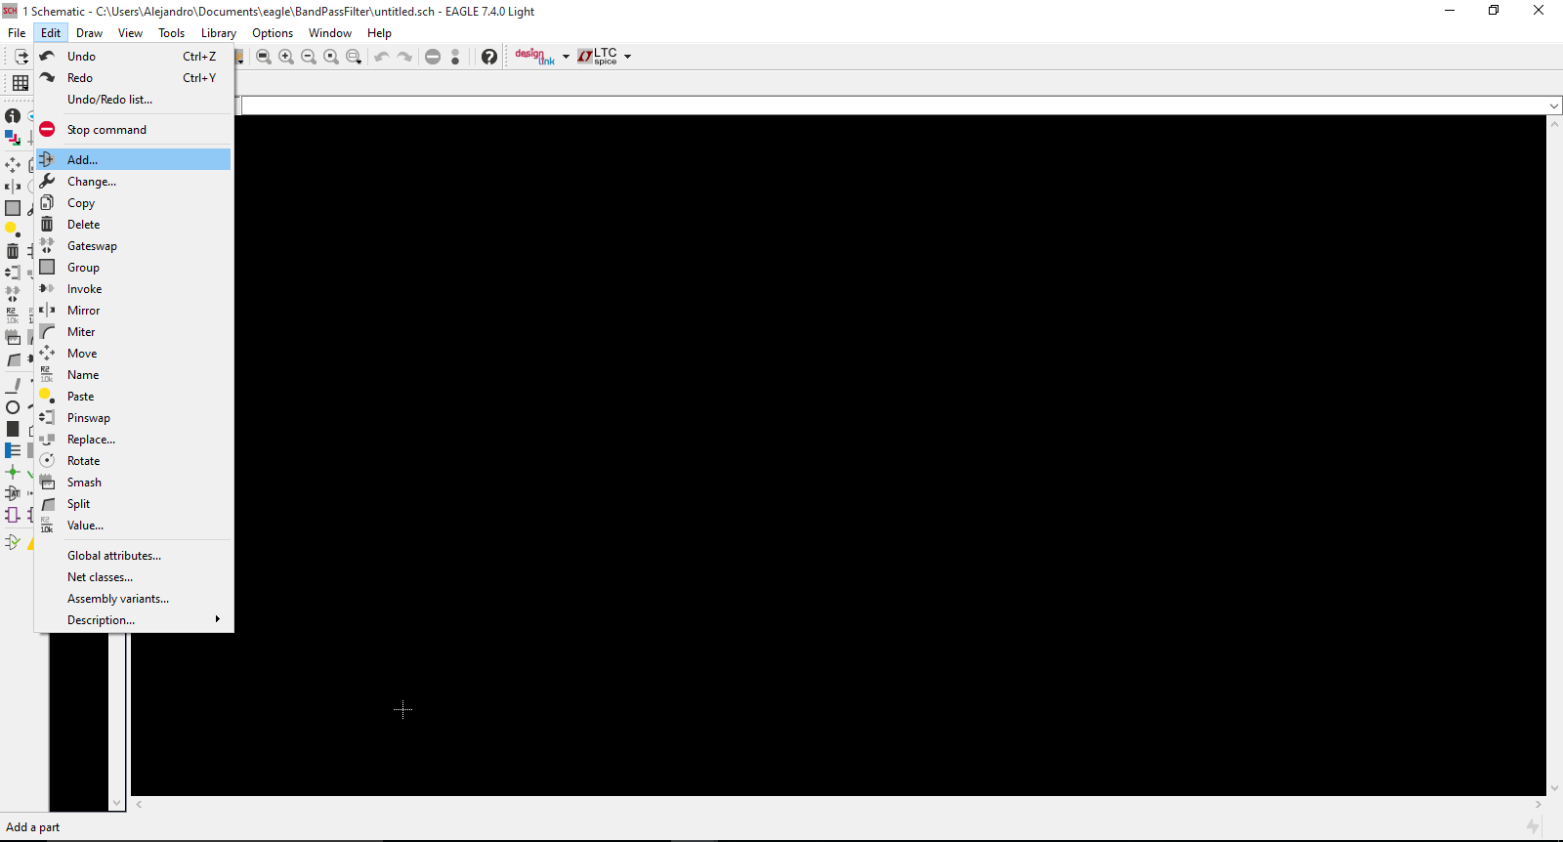

Fig 10: Adding a Component in the Schematic Window

After clicking, a window will be shown where a list of components (i.e. Resistors, Capacitors, etc.) will be listed. Click on the component necessary for the schematic and press OK on the bottom right of the menu to begin placing the component. To place the component, click in the white or black area of the schematic window as many times as you want that specific component in the schematic. For example, if you want two resistors then with the resistor component click in the white or black area two times (See Figure Below).

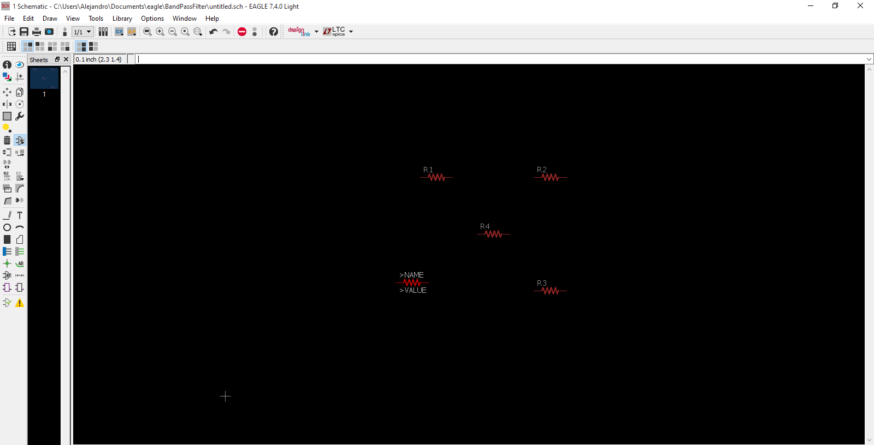

Fig 11: Placing Resistors in the Schematic Window

After placing the component, press the ESC key on the keyboard which will lead back to the component selection menu. If more components are necessary then repeat the previous steps. Once all the components are placed for the schematic, the next step is to connect them. Click on Draw >> Net for wiring components. To wire components, click on the end of one component and connect the wire to the end of the other (See Figure Below). Also, a node can be created by clicking on the end of one component and connecting the wire to another existing wire.

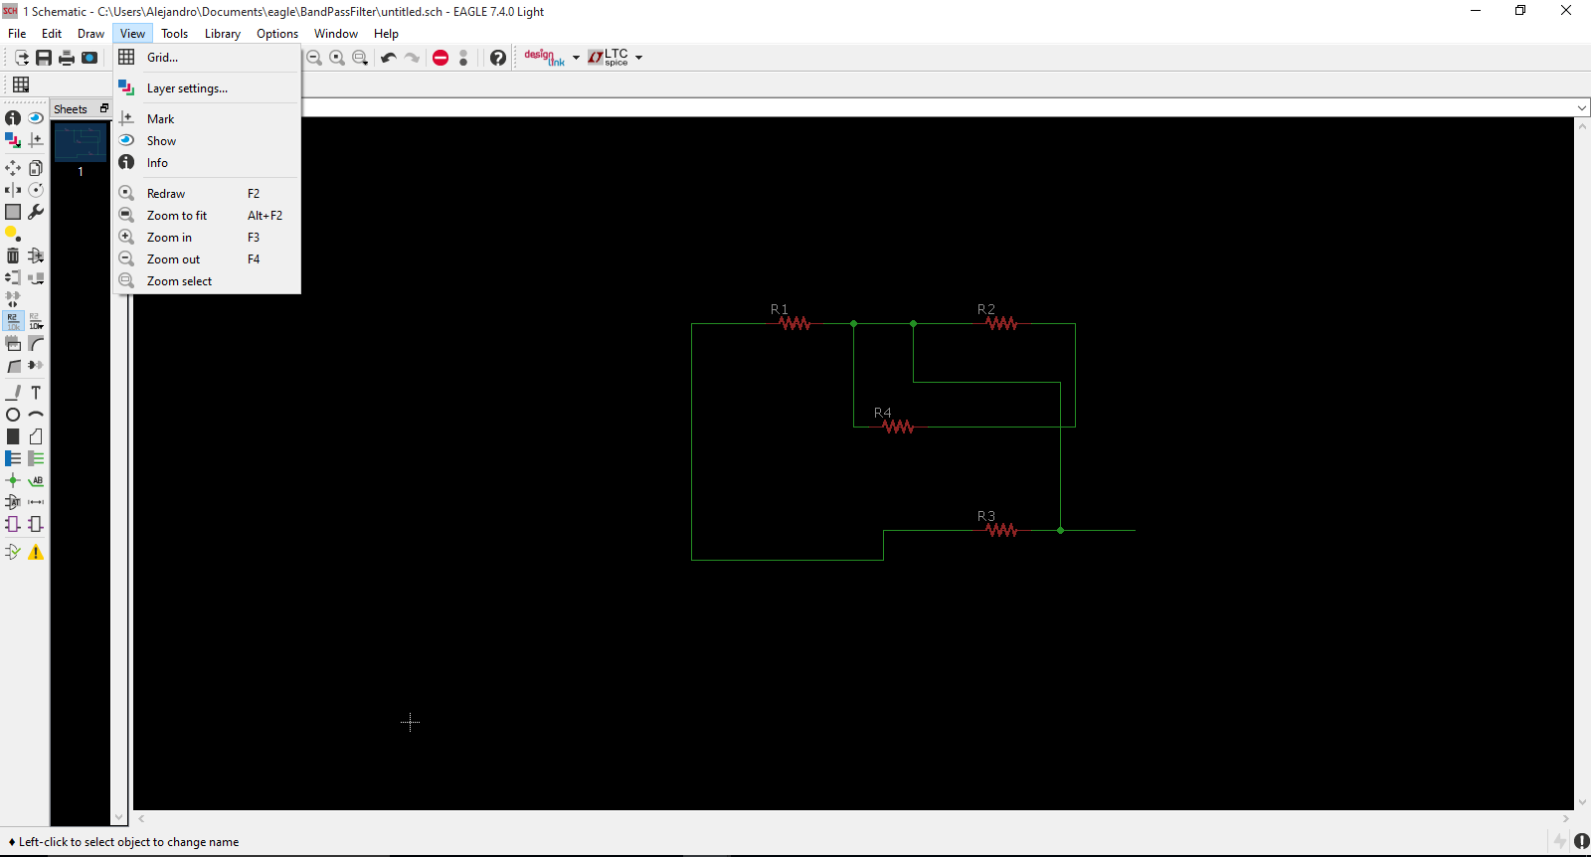

Fig 12: Completed Schematic

Another method of connecting a wire is by renaming the wire created to the exact same name of the existing wire. To use this method first create a wire, but do not connect the wire to any other component. Next, Right Click on the wire that has been created and press Name. Rename the wire to the exact name of the wire you wish to connect to. The name can be seen by Right Click >> Properties of the wire to see the name of and the name will be displayed in the Name textbox under Net. After renaming the wire, a warning will appear asking if the connection between the two wires is desired. Once confirmed, the wires are now connected.

**Caution: In Eagle, when connecting components, the Net function is used to physically connect the components. There is a Wire function that just draws a line. Make sure to use Net and not Wire for connecting components.**

To check if all the connections are correct the Show function may be used which displays all the connections. Click on View >> Show then click on the connection to observe to see all the connections (See Figure Below).

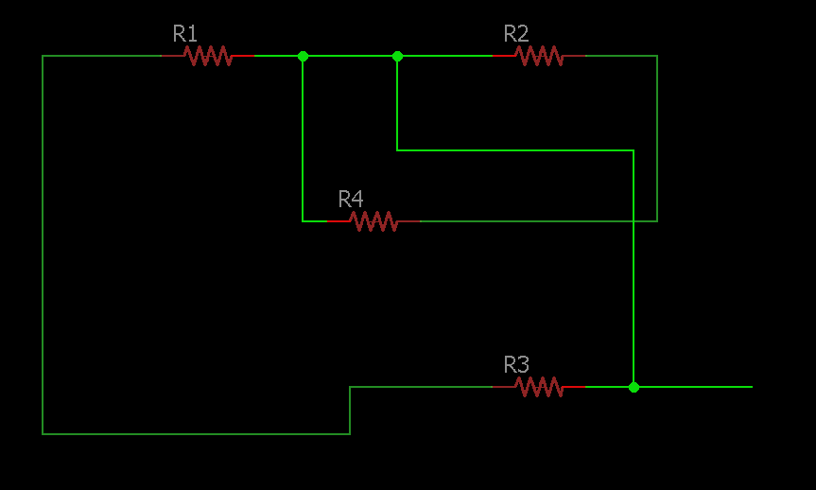

Fig 13: Showing all the Connections with the Show Function

After checking for proper configuration and the schematic is complete, a board layout can be created. To create the board layout click on File >> Switch to Board to switch into the board layout view (See Figure Below).

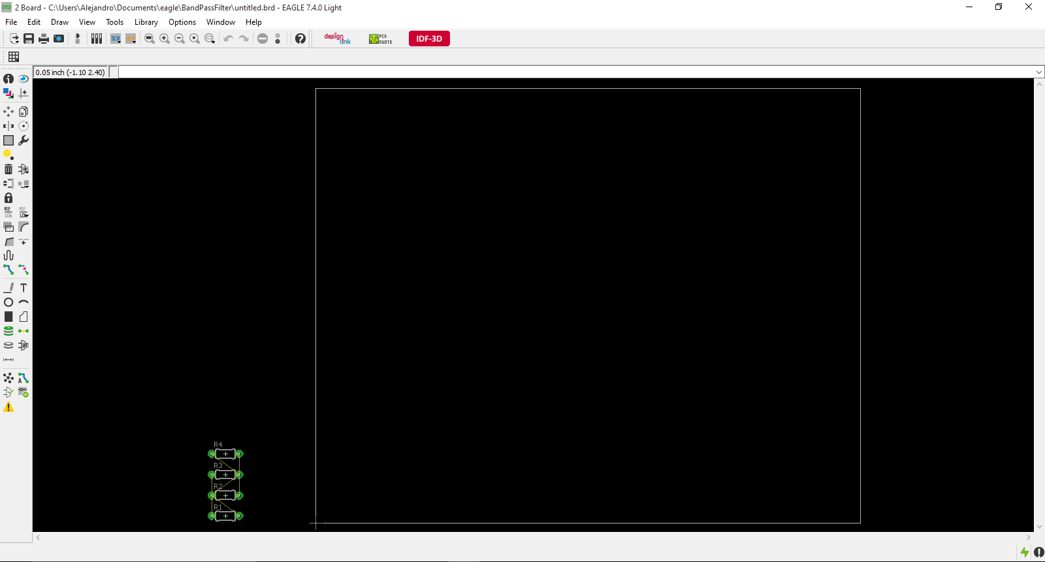

Fig 14: Board Layout View

The board components will be grouped together as seen from Figure 14. To move them click on Edit >> Move and configure them in a manner that takes into account any physical constraints that the board may have as well as the physical dimensions of the components.

In the Edit menu there is many functions that can be used to create the board layout such as:

* Route – Creates physical connections between components (Similar to Net)
* Ripup – Deletes connections between components (**Must be used to delete Routes**)
* Group – Groups the selected items
* Delete – Removes components or other items

The main functions used will be Route, Ripup and Move to complete the board layout (See Figure Below).

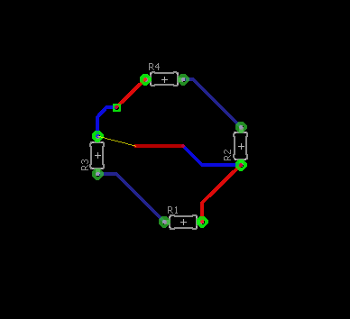

Fig 15: Board Layout in Progress

The yellow wire that is not a route is called an airwire which is a helpful tool that is automatically done in the board view (See Figure 15 above). The purpose of airwires is to show the connections that still need to be made for the board as well as error checking. To use airwires for error checking use the Ratsnest function (Tools >> Ratsnest) which will reconfigure the airwires, display remaining connections, and display if there is no connections left to be made. Ratsnest can be helpful when routing large PCB layouts. Another error checking tool is Design Rule Check (DRC) where a list of parameters can be inputted or a file with the dru extension can be loaded and the DRC will check those conditions on a board layout. To use DRC function click on Tools >> DRC… and a DRC window will be displayed. Input all the parameters that are desired to have met and click Check or click Save as… to save the list of requirements for later use. After, clicking on Check the board layout window will have a display on the bottom right (See Figure Below).

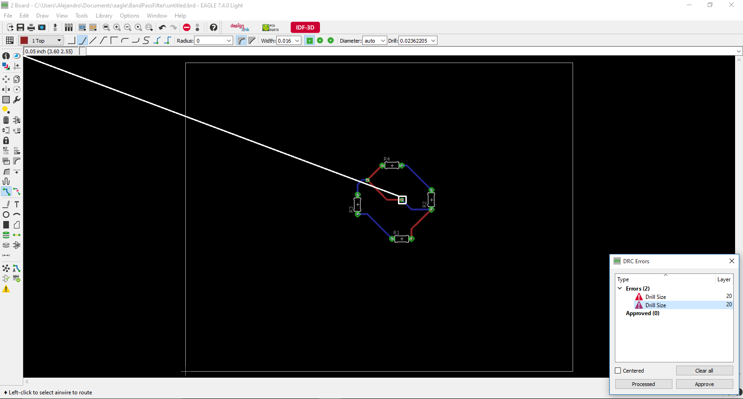

Fig 16: Design Rule Check (DRC) is being used for Error Checking

The display will show all the necessary corrections that need to be made according to the specifications that were given. If no corrections are needed then the DRC will display a message on the bottom left of the board layout window which says, “DRC: No Errors”

After completing the PCB layout and error checking then Gerber files need to be generated. To generate Gerber files click on File >> CAM Processor… and a window will be shown. Next, input a set of parameters or load a file with the cam extension to specify how to generate the file. After all the parameters have been set, click on Process Job on the bottom of the display to generate all the Gerber files. Now that the Gerber files have been generated the files can be used to mill the board in Circuit Pro.

Circuit Pro

To begin, first turn on the Milling Machine that will be used as well as connected to the computer that Circuit Pro is installed on. Next, open Circuit Pro and a window will be shown (See Figure Below).

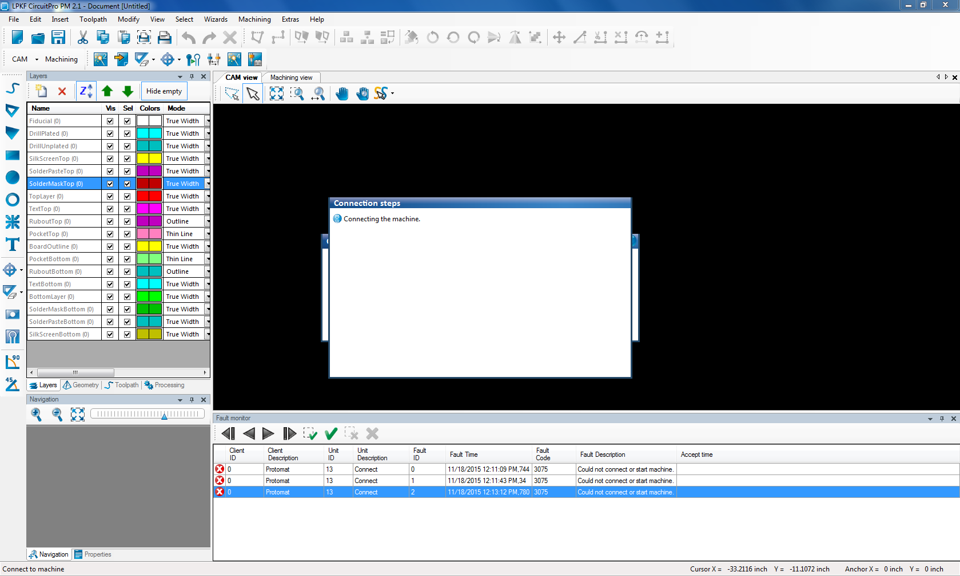

Fig 17: Circuit Pro Start Window

When Circuit Pro is opened, the first action that will be performed is to establish a connection to the Milling Machine currently connected to the computer. If this operation fails then an error message will be displayed where after exiting the messages a New Document window will be shown (See Figure Below).

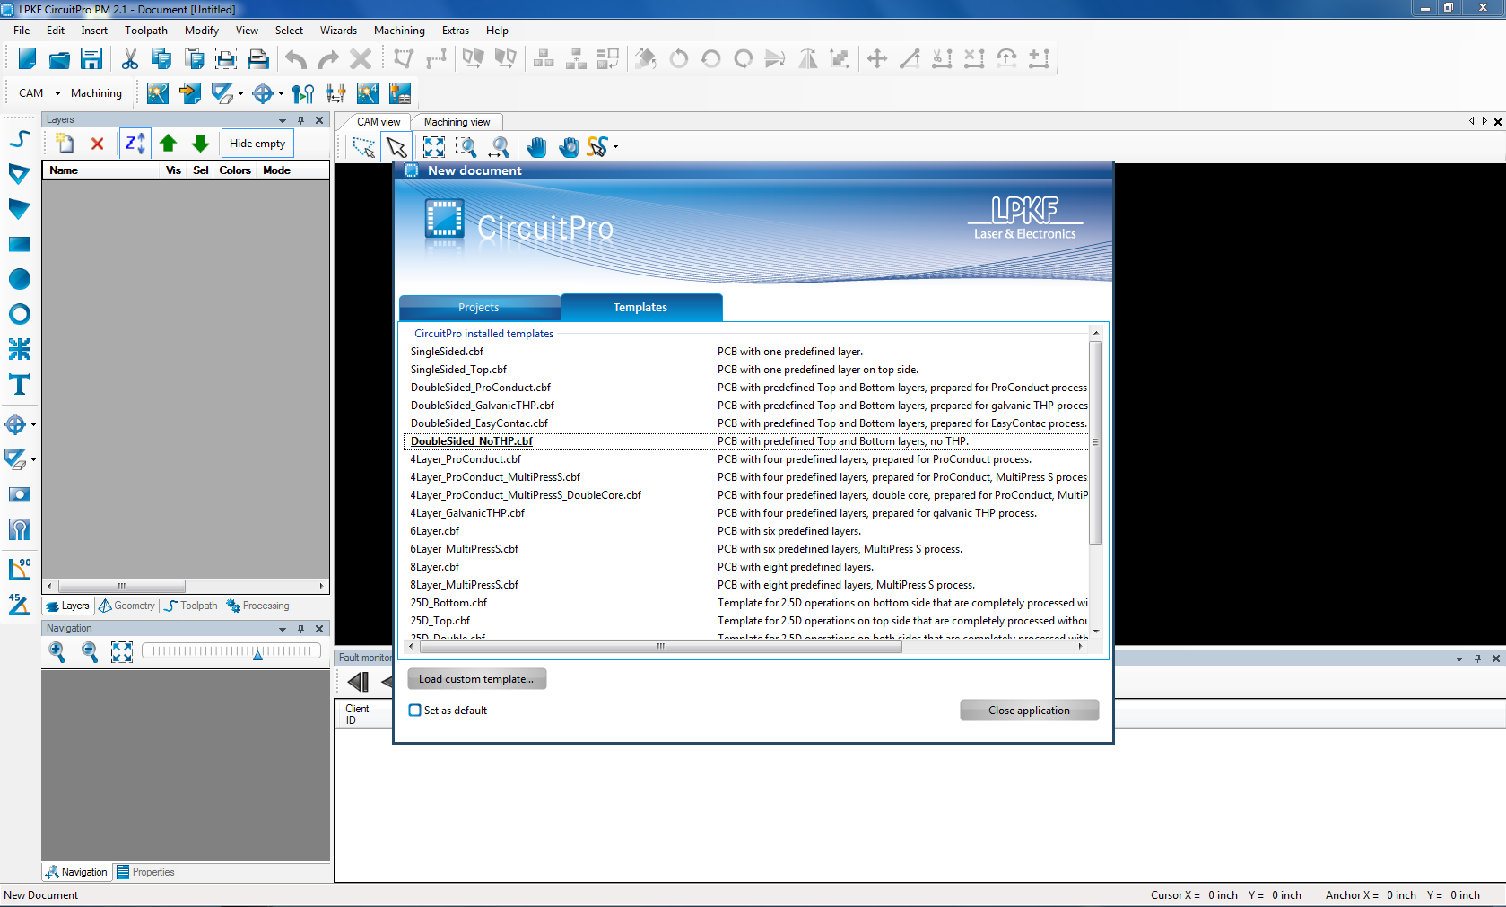

Fig 18: Template Display in Circuit Pro

In Templates tab there is a variety of board type to choose from where they have predefined layers for the board layout. If there is an existing project then the Projects tab will display all existing projects. After choosing a template, if Circuit Pro did not connect to the Milling Machine previously then this can be re-attempted by clicking on Machining >> Connect… where a message will be shown asking for the Machine Model. After choosing the model, click on Connect on the bottom left of the message and Circuit Pro will attempt to connect to the Machine. If this did not work then try to reconnect after some time to let the machine be recognized by the computer.

**Note: All the options that pertain to the Machine will be unavailable until the Machine is connected to Circuit Pro.**

Now let’s import the Gerber files that were previously created into Circuit Pro. To import files, click on File >> Import… and a window will be shown (See Figure Below).

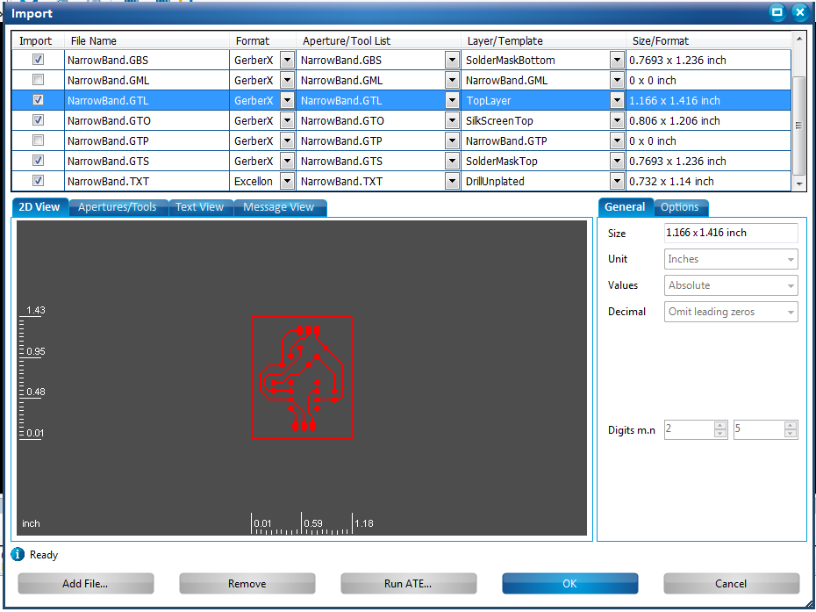

Fig 19: Import Window for Importing Gerber Files

In the Import window click on Add File… on the bottom right and select all the Gerber files that were previously generated. After adding the Gerber Files, in the Import window sort all the files into each respective layer as seen in Figure 19 above. Once done with the file sorting click on OK on the bottom right of the window. The board layout created will be imported and will be shown in the Cam View tab (See Figure Below).

# 

Fig 20: Imported Board Layout into Circuit Pro

Now that the board layout was imported, Circuit Pro must now calculate the routes and tools needed for the specific board layout being milled. To make the calculations click on Toolpath >> Technology Dialog where a window will be displayed. In the window change and set all the necessary parameters for the board layout such as Insulation, Fiducials, Contour Routing, etc. Next, click on Start on the bottom right of the window where after a brief moment the window will display the results of the calculation. Close the Results window and begin the milling process.

**Note: The Milling Process requires that the Machine is connected to Circuit Pro.**

To begin Milling click on Machining >> Processing All where there will be a series of on screen directions to follow which include Defining Material Properties (i.e. Thickness), Duplication, Tool Exchange, etc. After this is complete then the board will be completed and milled.

For more information visit https://learn.sparkfun.com/tutorials/using-eagle-schematic.

# Acknowledgment

The authors would like to thank Crane Johnson with the National Oceanic and Atmospheric Administration (NOAA), along with Matthew Kupilik, Todd Petersen, Jens Munk, Radian Belu, and Joe Mixsell with special thanks to Aicha Elshabini with the University of Alaska Anchorage.

# References

1. "Arduino Pro Mini." Arduino. N.p., 2015. Web. 18 Oct. 2015. https://www.arduino.cc/en/Main/ArduinoBoardProMini
2. "Board Layout." Using EAGLE. Sparkfun. Web. 20 Oct. 2015. https://learn.sparkfun.com/tutorials/using-eagle-board-layout
3. CadSoft (2011). CadSoft: EAGLE (Version 7.4.0) [Software]. Available from http://www.cadsoftusa.com
4. "Iridium 9603." (n.d.): n. pag. Web. 18 Oct. 2015. http://www.rock7mobile.com/downloads/Iridium9603_Brochure.pdf
5. "LT1963A Series." Linear Technology. N.p., 2015. Web. 18 Oct. 2015. http://www.linear.com/product/LT1963A
6. J, Crane. "IGage Eagle Board Files." GitHub. Crane Johnson, 2014. Web. 18 Oct. 2015. <https://github.com/cranejohnson/iGage_hardware>
7. "Schematic." Using EAGLE. Sparkfun. Web. 20 Oct. 2015. https://learn.sparkfun.com/tutorials/using-eagle-schematic
8. “Ultrasonic Sensors.” Maxbotix. 2015 Web 12 Dec, 2015. http://www.maxbotix.com/Ultrasonic_Sensors/MB7386.htm
9. “Real-Time Clock.” Maxim Integrated. 2015 Web 12 Dec, 2015. http://datasheets.maximintegrated.com/en/ds/DS1307.pdf
10. “Programmable Resolution 1-Wire Digital Thermometer.” Maxim Integrated. 2008 Web 12 Dec, 2015.

https://datasheets.maximintegrated.com/en/ds/DS18B20.pdf

1. “Reliable EEProm Memory.” Microchip. 2014 Web 12 Dec, 2015.

http://www.microchip.com/wwwproducts/Devices.aspx?product=24LC1025

1. “Iridium 9602 SBD Transceiver Developer’s Guide.” Iridium. 2012 Web 12 Dec, 2015.

http://www.g-layer.com.au/wp-content/uploads/IRDM_9602DeveloperGuideV4_DEVGUIDE_Sep2012.pdf

1. This paper was submitted for review on December 11, 2015 and was supported by the University of Alaska Anchorage. A. Johnson-Eusebio is as student at the University of Alaska Anchorage with minors in math and physics who will also be attending a master’s program in Electrical Engineering in the future. (e-mail: ajohnsoneusebio@alaska.edu). J. Shafer student at the University of Alaska Anchorage graduating with a degree in Electrical Engineering with a minor in math. (e-mail: jrshafer@alaska.edu).