Outreach
Project: Raspberry Road Rehabilitation Project
Community partner: Alaska Department of Transportation & Public Facilities (AKDOT&PF)
Project Lead: Eric Miyashiro, P.E., AKDOT&PF
Robert DeVassie, P.E., AKDOT&PF
Osama A. Abaza, Ph.D., Professor and Chair of Civil Engineering, UAA
Project team: Stefanie Armstrong (Project Manager), Corey Prewett, Amanda Del Frate, Christy Meyn, Ryan Kim, Branden Hafele, George Randy Lenig, Travis Thompson, Andrew Gray

Abstract: In partnership with the Department of Transportation and Public Facilities DOT&PF, and industry professionals this project group completed a Design Study Report (DSR), a design planset complete with typical sections and singing and stripping drawings that specifically focused on the health, safety, and wellness of; drivers, non-motorized operators, and pedestrians within a municipality that did not currently have a solution to high speed vehicle interaction with a non-signed, and a non-lit cross walk.
The project is 1.5 miles long with a variety of problems associated with it as outlined below. Severely degraded pavement; ruts 3-4 inches deep, “humps” in the road, transverse cracks extending from one sidewalk to the opposite sidewalk, longitudinal cracks, overlay delamination, pavement failures requiring soil digouts, and alligator cracks. In addition to the pavement rehabilitation, the project site needed major upgrades to bus stop pullouts, and pedestrian and bicycle facilities.
Significant past public comment on the project location required our site to be added the the Municipal Master Plan for any future development to include on-road bicycle facilities. However this road does not meet FWHA/AASHTO design standards for vehicles that are above 40 miles an hour that need to cross paths with pedestrians and bicyclists that are using the multi-use pathway that runs parallel to the road surface, until it reaches the on-ramp for the highway. Thus the need for a unique design that solved those problems and was outside the normal design guidelines for the DOT&PF.
The design solutions selected for our project, included re-pavement of the entire road surface with replacement of soil at multiple digout locations, and a roundabout at a street. Additionally to solve the health and human safety concern, on-road bicycle facilities were designed but with bike boxes to transition from the right side of the road to the left side at a street light until they bicyclist passes the unsafe zone, where it transitions back to on-road right side bicycle lanes. The approach made within the DSR included the recommendation that the DOT&PF in our Municipality apply for a funded “study” to allow for the trial and implementation of such a design while the Municipality votes to approve NACTO Bicycle Design standards.
The National Association of City Transportation Officials (NACTO) says that a bix box “increases visibility of bicyclists, facilitates bicyclist left lane turn positioning at intersections during red light signal indications, helps prevent ‘right-hook’ conflicts with turning vehicles at the start of the green indication, provides priority for bicyclists, and pedestrians benefit from reduced vehicle encroachment into the crosswalk.”
The estimated cost of the project upgrade is roughly $7.8 Million.
Seawolf Engineering 2015, having been awarded this project by AKDOT&PF, agreed to complete the following deliverables by April 2015:
- Designed sidewalks that meet ADA compliance
- Cross street turning radius’ that meet ADA compliance
- Pavement Design
- ESAL Calculations
- Traffic Analysis Calculations
- Level of Services of A-C today and 20 years from now
- On-Road Bicycle Facilities
- New Signing and Striping plans
- TIC Estimate for Preliminary Engineering, ROW, Utility Relocates, and Construction
- Plan set
- Design Study Report

Project Documents:
Team Photograph

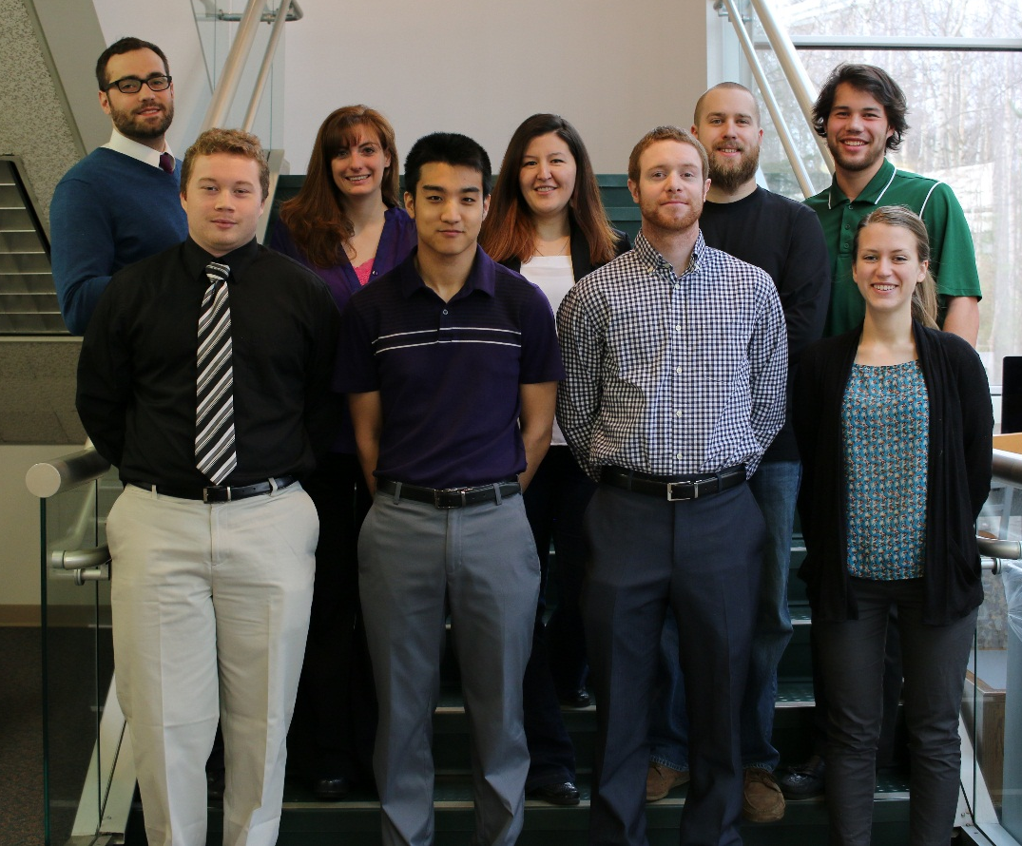

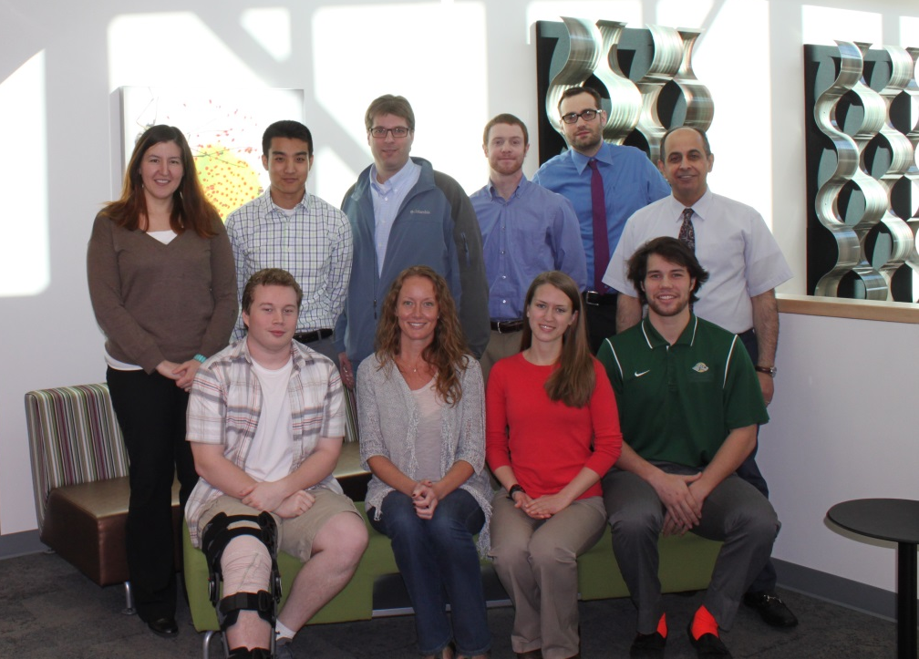

Vicinity Map
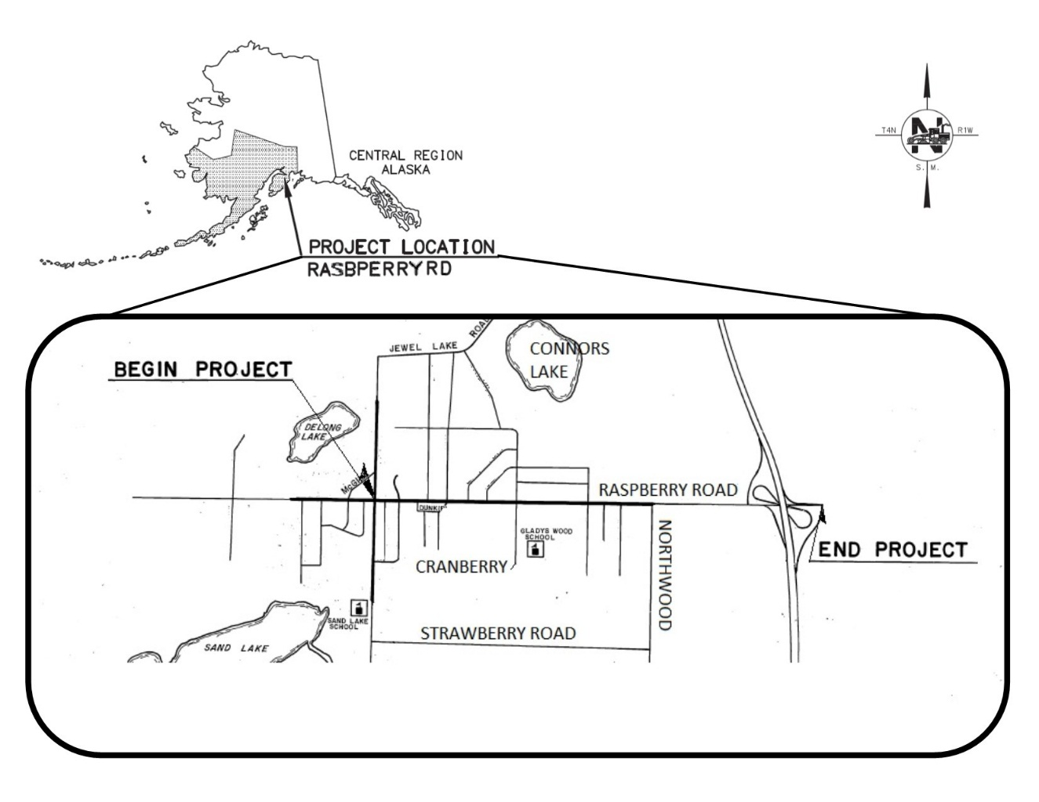

NACTO Bike Box Diagram
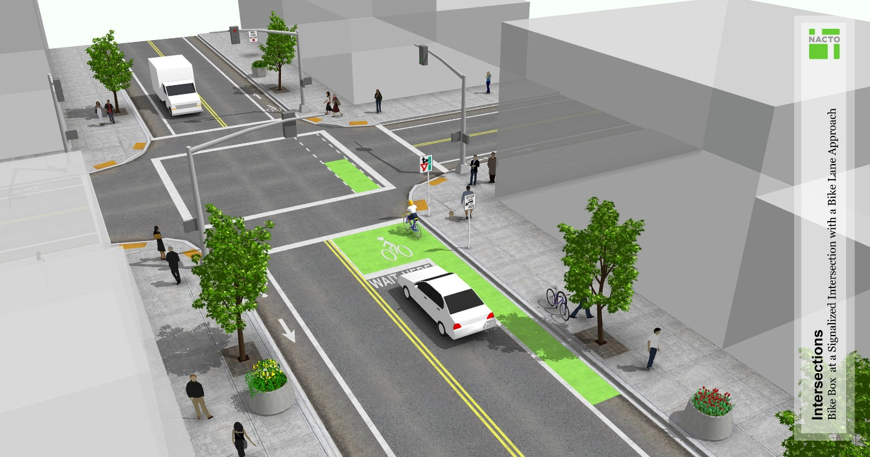

Left Lane Bicycle Lanes

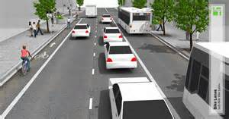

East End of Project
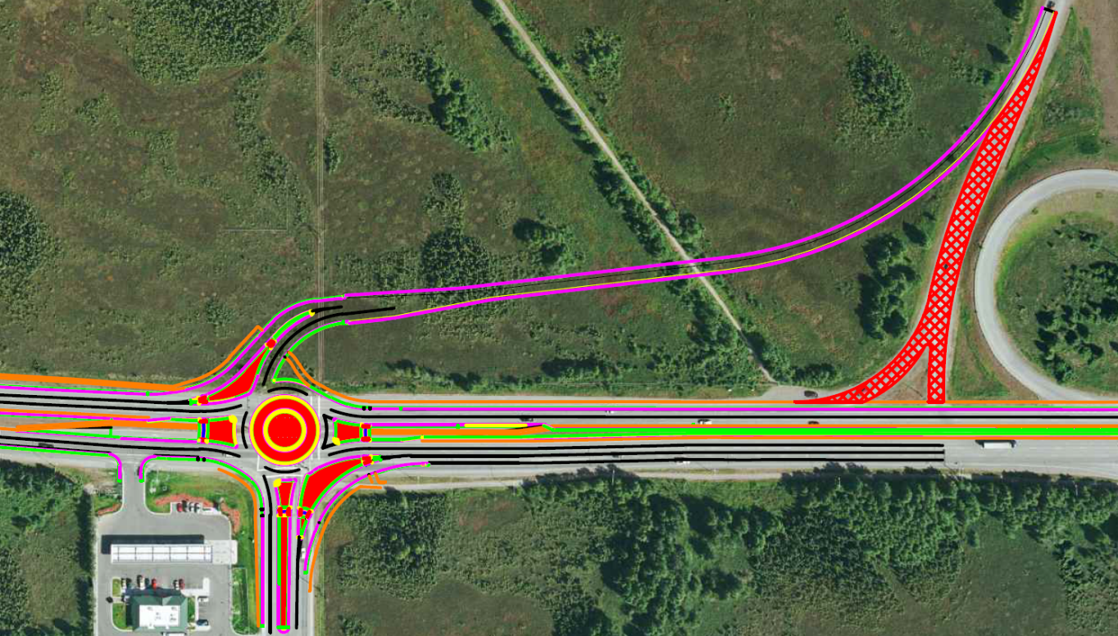

QR Code for our link to our website

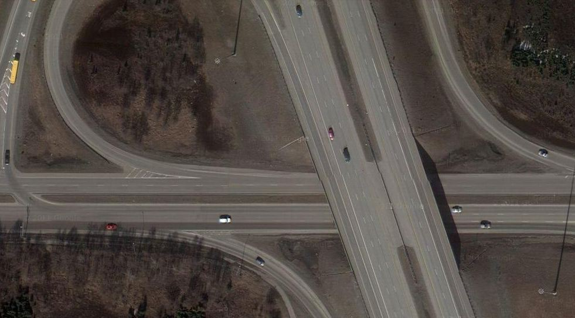
Proposed bike lanes
Multi-use Pathway
Existing Pedestrian Traffic
45 mph on-ramp

