SAE Baja Group: Final Report
EE A438
Muluneh Babiso
Bradley Ewers
Shawn Marshall
Tyler Tremont
Nick Tuchscherer

Friday, December 11, 2015

ABSTRACT
The purpose of this report is to present a Final report for EE A438 Design of Electrical Engineering Systems. The project our group was tasked with was to design and implement a tachometer and speedometer for the Mechanical Engineering (ME) department’s Baja. The project is broken up into three tasks: measuring the mph of the vehicle, measuring the rpm of the motor, and a digital system whose inputs (and outputs are logged) are the mph and rpm previously stated and whose outputs are tachometer and speedometer displays to the driver. All three tasks have been completed up to the point of being ready to be housed and mounted onto the Baja. Unfortunately due to time constraints, housing and mounting will have to be done either by another senior design group or the ME department.
TABLE OF CONTENTS
1.0 INTRODUCTION 3
1.1 INTRODUCTORY STATEMENT 3
1.2 PROJECT DESCRIPTION 3
1.3 TASK BREAKDOWN 3
2.0 TASK ONE – VEHICLE MPH 4
2.1 INTRODUCTION 4
2.2 DESIGN METHODOLOGY 4
2.3 ANALYSIS 4
3.0 TASK TWO – ENGINE RPM, METHOD ONE 7
3.1 INTRODUCTION 7
3.2 DESIGN METHODOLOGY AND ANALYSIS 7
3.3 BILL OF MATERIALS 13
4.0 TASK TWO – ENGINE RPM, METHOD TWO 14
4.1 INTRODUCTION 14
4.2 DESIGN METHODOLOGY 14
4.4 ANALYSIS 14
5.0 TASK THREE - MICROCONTROLLER 17
5.1 INTRODUCTION 17
5.2 DESIGN METHODOLOGY 17
5.3 ANALYSIS 19
6.0 CONCLUSION 21
7.0 REFERENCES 22
8.0 APPENDIX A 23
8.1 ARDUINO SOURCE CODE 23
9.0 APPENDIX B 23
9.1 FUTURE ARDUINO PSEUDOCODE 29

1.0 INTRODUCTION
1.1 INTRODUCTORY STATEMENT
The purpose of this report is to present the Baja RPM and MPH meters’ final report for EE A438 Design of Electrical Engineering Systems. This status report will cover the progress of the design project from initial project description to expected final implementation, deliverables, and future work.
1.2 PROJECT DESCRIPTION
The project our group was tasked with was to design and implement a tachometer and speedometer for the Mechanical Engineering (ME) department’s Baja. The Baja is an off-road ten-horsepower vehicle designed and built by UAA ME students for the Society of Automotive Engineers’ (SAE) yearly competition. Our system would measure the rotations per minute (RPM) of the engine and mile per hour (MPH) of the vehicle and display these numbers to the driver. The system would also act as a data acquisition (DAQ) system for the mph and rpm of the Baja. A gas gauge would also be implemented if possible. The project’s design and final implementation must adhere to SAE rules as well as non-specified goals added along the way. This project is expected to deliver a fully implemented system as described onto the Baja and a final report and presentation.

1.3 TASK BREAKDOWN
There are three main tasks to be distributed between the five project members; measuring the mph of the vehicle, measuring the rpm of the motor, and a digital system whose inputs (and outputs are logged in the DAQ) are the mph and rpm previously stated and whose outputs are the tachometer and speedometer displays to the driver. The mph task has been given to Nick Tuchscherer, the rpm task has been given to Brad Ewers and Muluneh Babiso, and the digital system task has been given to Tyler Tremont and Sean Marshall.

2.0 TASK ONE - VEHICLE MPH
2.1 INTRODUCTION
One way of obtaining the mph of the Baja is by measuring the rpm of its wheel. The rpm of the wheel will be converted into mph by multiplying the rpm by whatever fraction of a mile the circumference of the wheel is and converting minutes to hours. There are at least a couple of ways to measure the rpm of the wheel, such as using optics or magnetic switches. One such optical method is using a photo-gate; an infrared beam between a transmitter and receiver which measures the time between the beam being blocked or unblocked. On the other hand, magnetic switches are great because they’ll work in the muddy and dusty conditions that the Baja will be operating in as opposed to tools that use optics which could be obstructed by such conditions.

2.2 DESIGN METHODOLOGY

Two different magnetic switches that can be used in this application are reed switches and Hall Effect sensors. Reed switches are two ferrous metal reeds that are sealed in a glass envelope. Reed switches can be configured so that in the absence of a magnetic field the metal contacts are either touching or are separated and when the proper magnetic field is introduced the contacts separate or touch, respectively. For this application, reed switches that close under a magnetic field are preferred. Hall Effect sensors make use of the Hall Effect where by a magnetic field passing perpendicular through a current carrying conductor will cause a potential difference in the conductor that is transverse to both the current and the magnetic field [1]. The Hall Effect sensor uses this principle to output a changing voltage depending on the strength of the magnetic field perpendicular to the sensor. For this application, a Hall Effect sensor with a digital output would be chosen.

Whether the reed switch or Hall effect sensor is chosen, the output of the system will be a square wave; low in the absence of a magnetic field and high in the presence of a magnetic field, or vice versa. The advantage of the reed switch is that they are cheap. The disadvantages are that because this is a mechanical system, the rise and fall times and switching cycles per lifetime are relatively slow/low depending on the frequency and load of the system. The advantages of Hall Effect sensors are because it is a solid state component, rise and fall time are faster and more lifetime switching cycles can be achieved. The disadvantage is that Hall Effect sensors are relatively much more expensive and have to be configured to give a digital output.

2.3 ANALYSIS

For this project, we ordered two reed switches and four Hall Effect sensors to test for best fit in this design. The parts were ordered from Digikey and the part numbers are 374-1166-ND, 374-1390-ND, 55110-3H-02-A-ND, and 55140-3H-02-A-ND for the two reed switches and two Hall Effect sensors respectively. The other two Hall Effect sensors were parts 620-1414-ND and 620-1411-ND, but the data-sheets were illegible and proper setup was not tested.

The configuration of the reed switches is to have each of them pulled to ground through a 10k ohm pull-down resistor and have their other lead attached to 5V. The output would come from the node connecting the reed switch to the pull-down resistor. When the switch comes into contact with a magnetic south pole of around 60 Gauss at about 5 mm away, the output would raise to the 5V supply voltage. Both reed switches behaved with the same results. When connecting the circuit to 5.23V and ground, the outputs were 230mV and 5.23V in the absence and presence of a magnet respectively. The rise and fall times of the output were at least as fast as 600 microseconds which is a frequency of 1666.7 Hz which is faster than the wheel would ever be going. The behavior of this system is precisely what we want to see; fast switching and high and low logic voltage outputs.

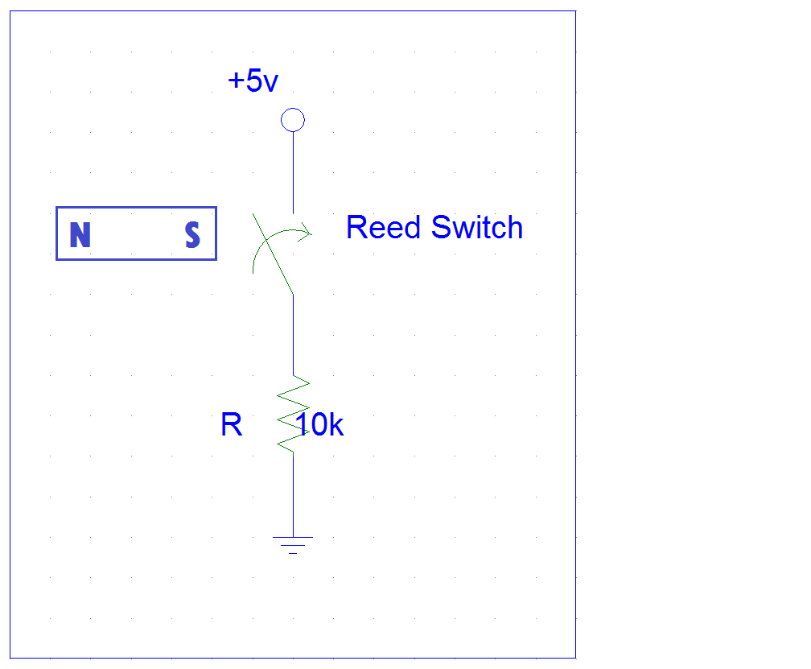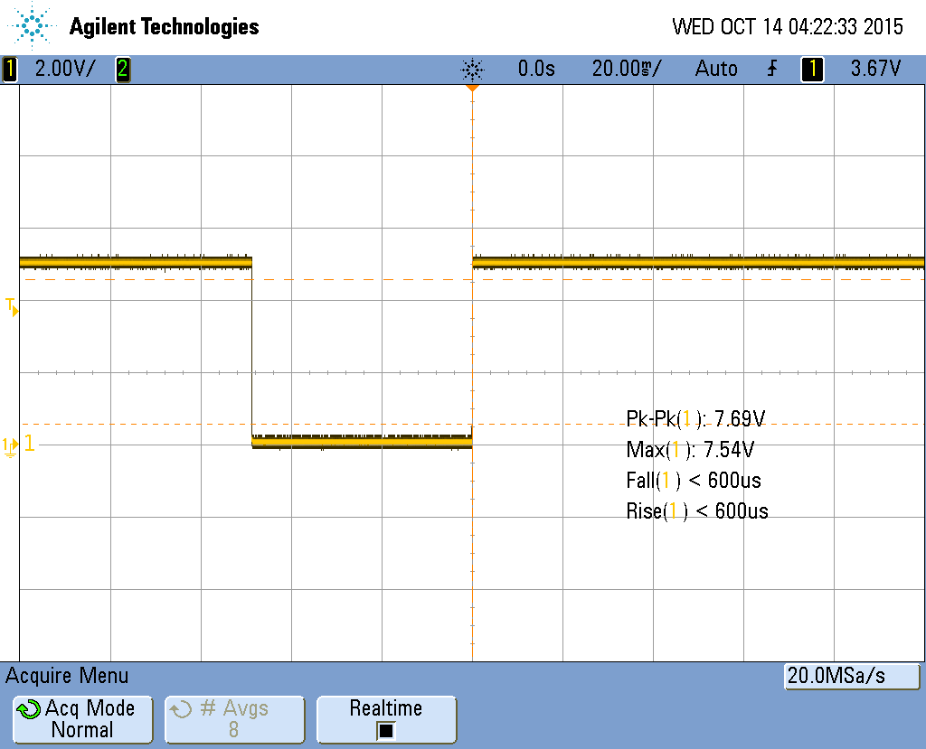

Figure 2.1 – Switch voltage divider switch Figure 2.2 – Square output of reed switch circuit

The configuration and outputs for 55110-3H-02-A-ND and 55140-3H-02-A-ND Hall effect sensors are slightly different but similar enough with similar results to cover them in the same paragraph to reduce redundancy. The 55110 sensor is the simplest of all the configurations as it has three leads that connect to Vcc, ground, and output without needing external components. The 55140 sensor also has these three leads but a pull-up resistor, 10k ohms was used, connecting the output to Vcc is required for proper functioning. Both circuits were
connected to 5.23V and ground. The 55110 gave outputs of 3.91V and 290mV in the absence and presence of a magnet respectively. The triggering distance was the same for the Hall Effect sensors as for the Reed switches. The 55140 gave outputs of 5.23V and 230mv likewise. For both of these circuits, the output was inverted relative to the reed switch circuit. If one of these circuits is to be used in the final product, this inversion of outputs will have to be taken into account either in the Arduino coding or an inverter, but if the Arduino were only looking for positive or negative transitions the inversion of the signal would not matter. Both of the circuits had rise and fall times of under 600 microseconds. Even though the outputs are inverted, these circuits are giving us fast switching and good high and low logic voltages that we want to see.

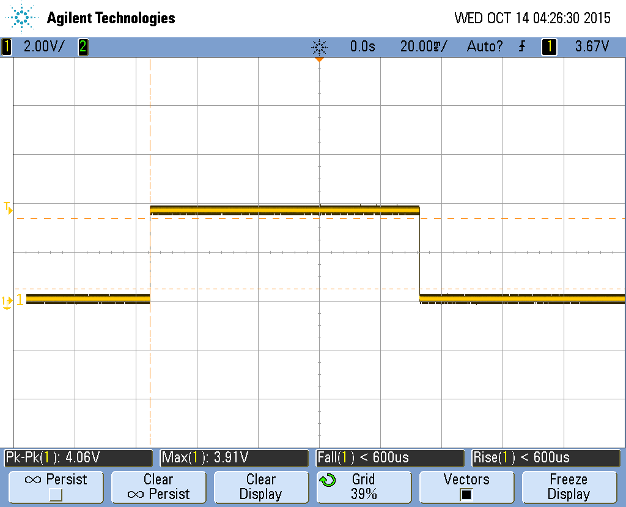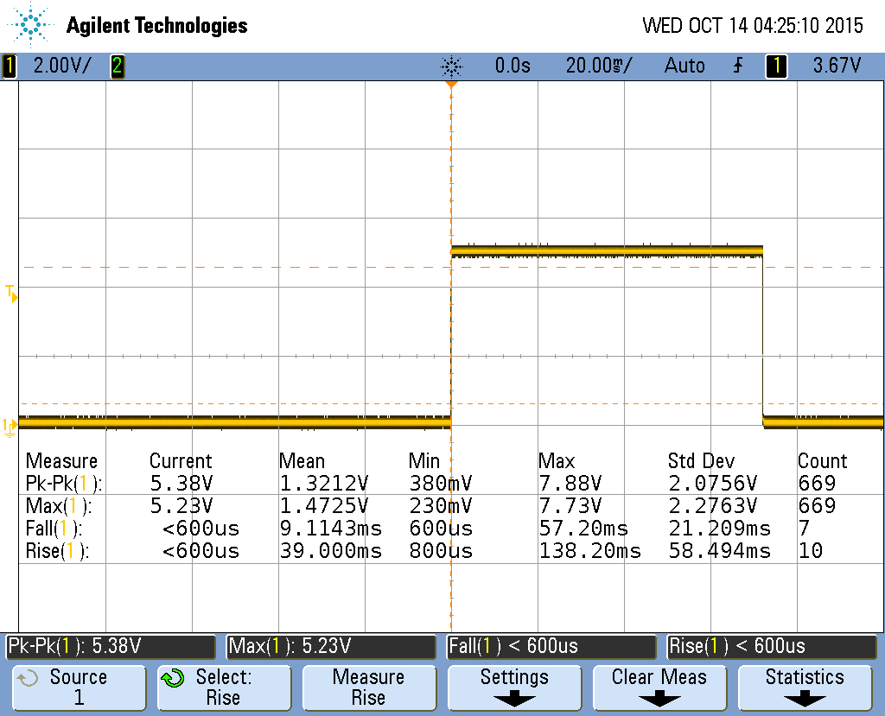

Figure 2.3 – 55110 square wave output Figure 2.4 – 55140 square wave output

The magnet that was used to trigger the reed switches and Hall effect sensors was from Honeywell with part number 102MG11, but a larger, curved rare earth magnet will be used in final implementation for its shape and increased magnetic field for improved distance between magnet and sensor.

Though all the equipment and configurations are giving desirable outputs, the 55110 sensor will be used. The 55110 sensor already has its own housing which can easily be mounted. It also has the simplest configuration and requires no external components. Due to time constraints, mounting of the sensor and field testing was not achieved. Below are diagrams of possible mounting places for the sensor and magnet. The mounting configure in the left picture (figure 7) would be preferred, because the rear drive shaft the magnet would be mounted on, as shown in figure 8, would be shifting around because it is adjoined to a CV joint.

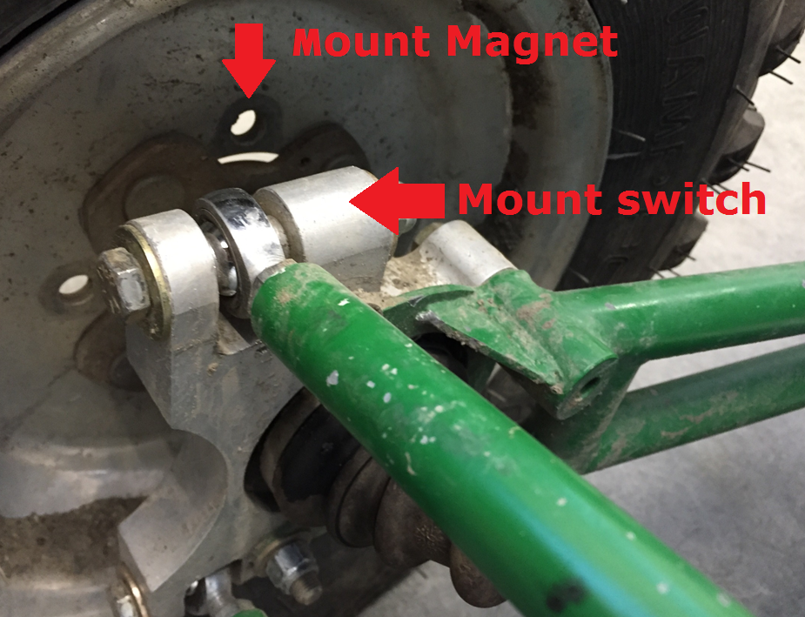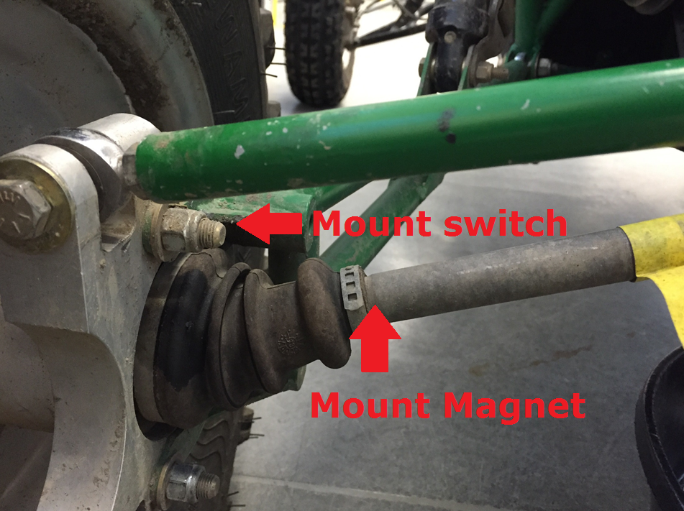

Figure 2.5 – Lug-Mount Location Figure 2.6 – Driveshaft Mount Location

3.0 TASK TWO - ENGINE RPM, METHOD ONE
3.1 INTRODUCTION
This section outlines the methodology of the design and construction of a circuit which will turn a spark plug signal from a capacitive pickup into a square-wave which will be readable by an Arduino microcontroller. SAE rules do not allow us access to the engine compartment so the only way to get a signal indicating engine RPM is from the spark plug wire. The original thought was a simple integrating circuit which would turn ideal pulses from the spark plug into a square-wave. As it turns out, the signal coming from the capacitive pickup is noisy and does not yield ideal delta functions. Thus, integrating the signal is out. The final goal is to be able to design an entire system which will be small enough to mount on to an SAE Baja vehicle. This means it must be small, removable, and simple enough for the students on the Baja team to be able to install and operate without the supervision of the students working on the design project. Through meetings with Dr. Mixsell, a base circuit design was developed which would give us a start in designing a circuit that would meet the criteria we desire. [2]
3.2 DESIGN METHODOLOGY AND ANALYSIS
The base circuit developed shown in Figure 3.1 uses mostly digital logic integrated circuits. Specifically, it uses an SR latch coupled with JK flip-flops to output a square-wave.

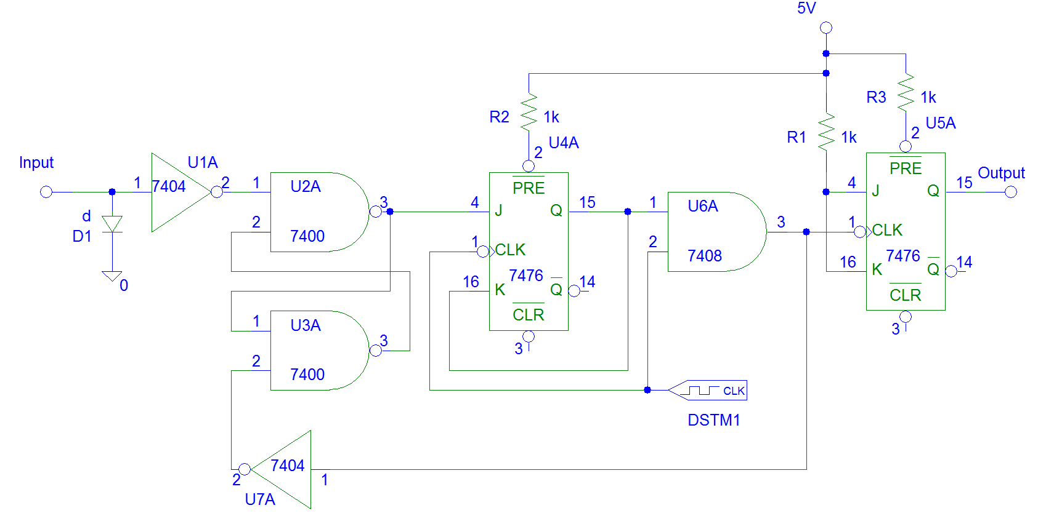
Figure 3.1 – Original Circuit Design

Overall, the final circuit and the original circuit are not that different from each other. The two key missing elements are the amplification and conditioning of the input signal coming from the spark plug pick-up, and some form of a delay stage.
The signal coming from the spark plug pick-up is itself, not enough to simply input into the circuit shown in Figure 1. Because we are using an SR latch, we will want the input signal from the pick-up to be rectified, and inverted so positive voltage spikes are actually negative. And because we are using digital circuitry, TTL voltage levels are ideal, meaning a range from zero to five volts. In order to accomplish the condition of the signal, LM324 operational amplifiers are used. The LM324 IC has four op-amps built into it – we will be requiring two. The first op-amp will amplify and rectify the incoming signal with an output range of zero to five volts. The second op-amp will further amplify and invert the signal around 2.5 volts so positive voltage rises from the spark plug pick-up are seen as negative voltage drops (from five to zero volts) by the SR latch. The conditioning circuit for this stage is shown in Figure 3.2.
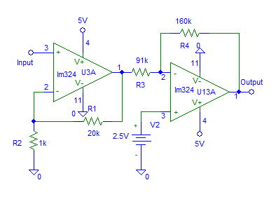
Figure 3.2 – Circuit for Amplification and Inversion of Input Signal

Figure 3.3 depicts the input waveform from the spark plug pick-up and also shows the outputs of each op-amp in Figure 3.2.

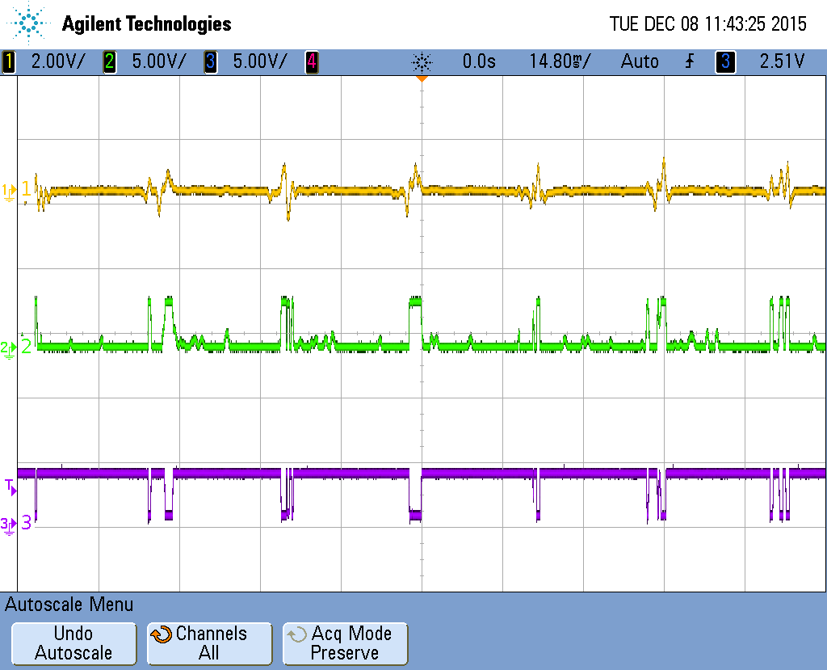
Figure 3.3 – Waveforms Generated by Spark Plug Pick-up and Amplification/Inversion Circuitry

There are three waveforms shown in Figure 3.3. The first, colored yellow, is the original signal from the capacitive pick-up. The second, colored green, is the amplified and rectified signal from the first op-amp. The third, colored purple, is the further amplified and inverted signal from the second op-amp. The gain of each op-amp is arbitrary in that as long as it rails out the signal at five volts, it is adequate. The gain is controlled by the input and feedback resistors of each op-amp stage. Mathematically, the gain can be represented by Equations 3.1 and 3.2. [3]
Eq. 3.1
Non- Eq. 3.2
The first op-amp has a gain of 21 while the second op-amp has a gain of approximately 1.75.
With the input signal from the spark plug pick-up successfully pre-conditioned, the SR latch can effectively use it as an input in order to turn the original signal into a square-wave. The SR latch will latch when the output of the amplifier stage is five volts (a logical “1”) and when the inverted reset signal is zero (a logical “0”). Not until these two conditions for “S” and “R” of the SR latch are input again, will the output of the latch change. Figures 3.4 and 3.5 depict the SR latch operation and the truth table is shown in Table 3.1. [4]

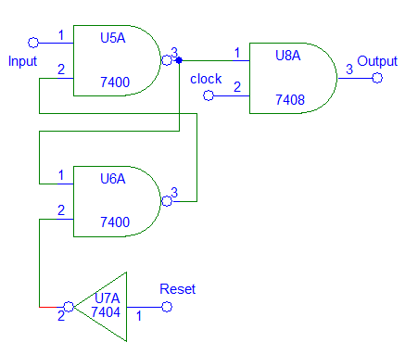
Figure 3.4 – SR Latch Circuitry

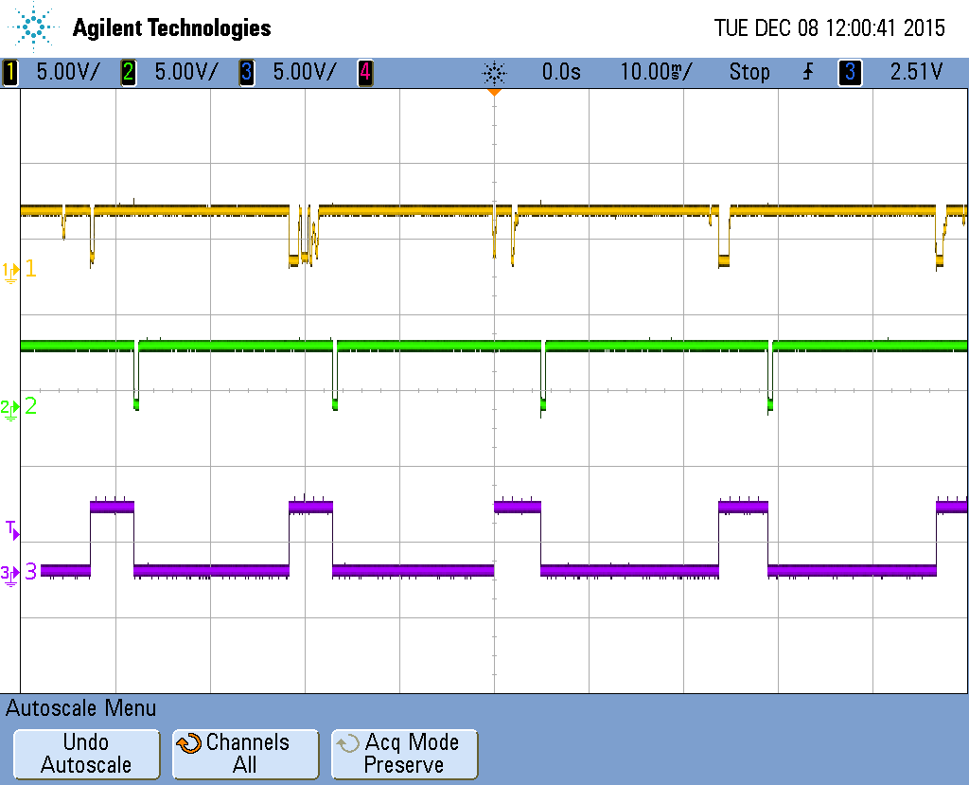
Figure 3.5 – Input and Output Waveforms of SR Latch

S | R | Q | Action
0 | 0 | Last Value - Latched | No Change
1 | 0 | 1 | Set
0 | 1 | 0 | Reset
1 | 1 | - | Invalid Condition

Table 3.1 – SR Latch Truth Table

The problem with using the SR Latch is that it will reset too frequently with the given input signal. What we are desiring is one reset event per pulse from the spark plug pick-up. In order to do this, we must devise a plan to add delay to the circuit that is at least as long as the time-span of a spark plug pick-up signal event. Using the oscilloscope, we were able to measure the time-span of the spark plug pulses and they ended up being approximately 6ms. This means our delay circuit needs to add at least 6ms of delay to the circuit before the SR latch resets. We were going to originally do this using a low-pass filter (LPF). This LPF would be placed between the “Q” output of the first JK flip-flop and input “1” of the AND gate shown in Figure 3.1. Using Equations 3.3 and 3.4, we would be able to solve for the resistor and capacitor needed to add 8ms of delay. [3] We chose 8ms of delay instead of 6ms to give more of a buffer between events.
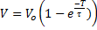 Eq. 3.3
Where
Eq. 3.4
Setting to 8ms, to 1V, to 5V, and solving for τ yielded τ equal to 35.9ms. This means the product of the resistance and capacitance of our RC circuit must equal 0.0359. In the laboratory, we have 0.1µF capacitors and chose a 36kΩ resistor to get τ. The only problem with using our digital circuits is that when the inputs and outputs are “high” or a logical “1”, they have a voltage. Through experimentation it was found that using an LPF to add delay to the circuit would not work since the outputs which it would be connected to retain a voltage which means the capacitor will not discharge at all. The solution to this problem is simple enough. Since we have control over what our clock signal is (in this case we chose 1 kHz) we can use a 4-bit Binary Adder to add delay. As the adder adds one bit every clock cycle, we get 8ms of delay after 8 clock cycles. By using the most-significant bit of the adder as the output of our delay circuit, we can add 8ms to the entire circuit thus achieving our desired output. After adding the binary adder to the circuit, we achieve what is shown in figure 3.6 – the final circuit design.

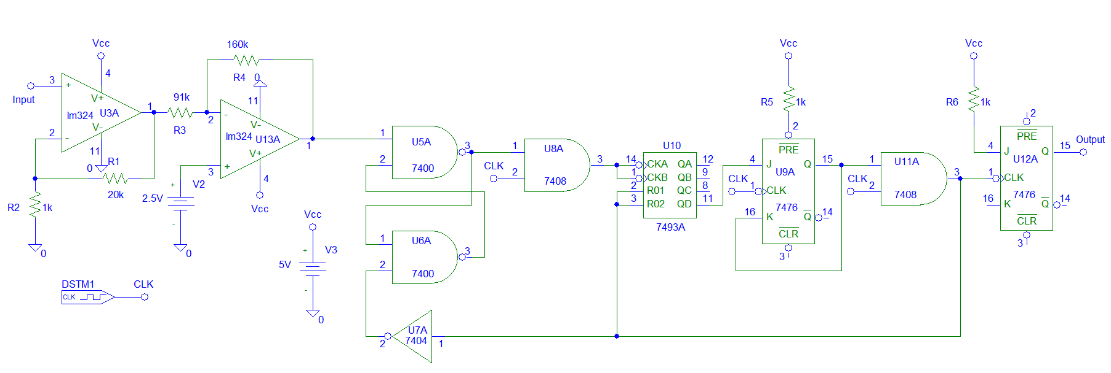
Figure 3.6 – Final Circuit Design for Signal Conditioning

The group members working on the source code for the Arduino microcontroller desired a square-wave as the output of our circuit. We were successfully able to achieve a clean square wave that is at half the frequency of signal events from the spark plug input signal, shown in Figure 3.7.
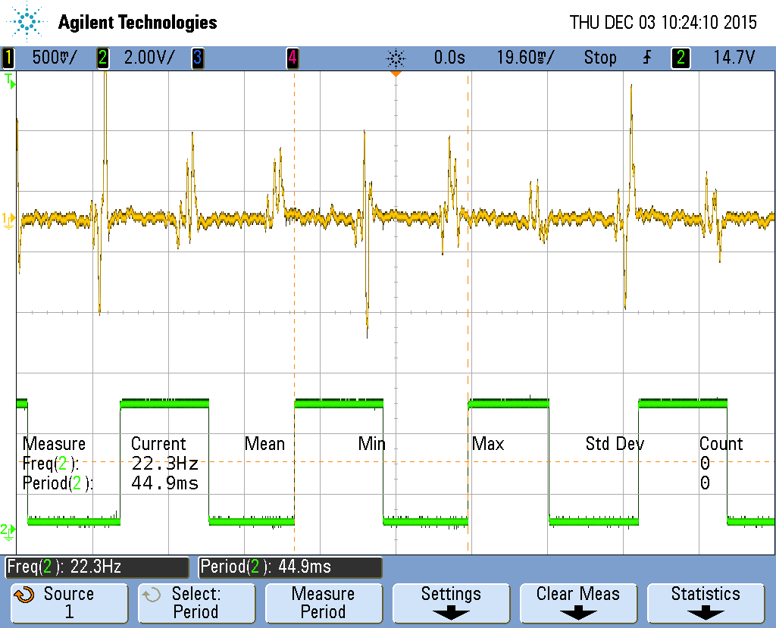
Figure 3.7 – Final Input and Output Waveforms

For testing of this circuit, power supplies and signal generators were used. If we are to mount this on the Baja vehicle, we will need to design a little more circuitry for power sources, specifically 5V and 2.5V supplies. The team members working on the Arduino source code should be able to implement a 1 kHz clock output from the Arduino board itself.
3.3 BILL OF MATERIALS
- LM324N Op-Amp I.C.
- SN74LS00N 2-Input NAND I.C.
- DM74LS04N INV I.C.
- SN74LS08N 2-Input AND I.C.
- HD74LS76AP J-K Flip-Flop I.C.
- HD74LS93P 4-Bit Binary Counter I.C.
- 3 x 1kΩ Resistor, 5% Tolerance
- 1 x 20kΩ Resistor, 5% Tolerance
- 1 x 91kΩ Resistor, 5% Tolerance
- 1 x 100kΩ Resistor, 5% Tolerance

4.0 TASK TWO - ENGINE RPM, METHOD TWO
4.1 INTRODUCTION
This was the second method for measuring the Baja engine rpm using the spark plug current coupling method. This design was cost effective and back up for the first design.
4.1 DESIGN METHODOLOGY
We chose to measure current flowing through the spark plug. This is due to the fact that the rate of the spark plug’s current spikes has a direct proportionality with the engine rpm. There were two ways of detecting the current signal; capacitive coupling with a pick up wire and current transformer. Both methods gave very similar results; a noisy voltage signal with periodic spikes. The wave form picked up from the sensors was too noisy for the Arduino group to measure the timing of the events. We needed some analog and digital circuitry to up clean the noise.
4.2 ANALYSIS
We used Monostable -555 timer to clean up the noise. The oscillator-timer was cheap and simple to use for this design. We tested the design on Spice first before we tested it on a circuit board. The Spice results were satisfactory to proceed for building and testing the circuit.

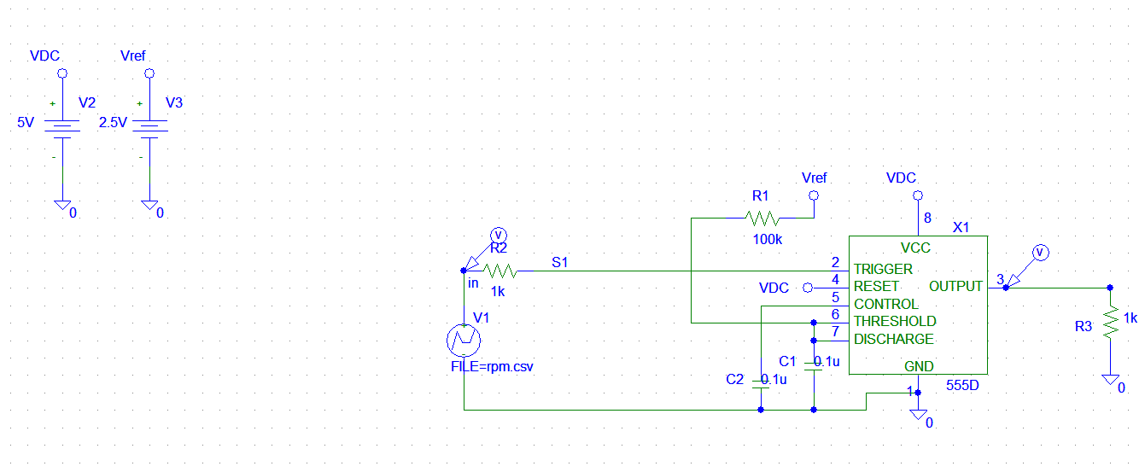
Figure 4.1 - Pspice schematic diagram for monostable-555 timer
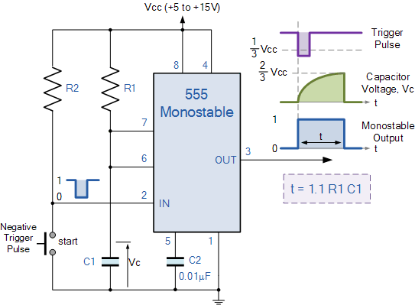
Figure 4.2. Monostable -555 timer
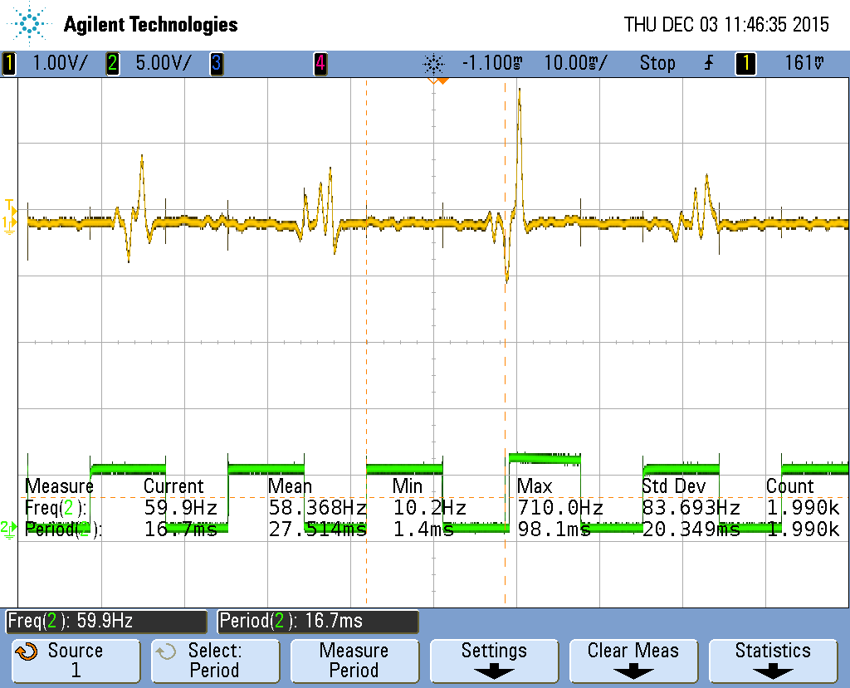
Fig 4.3 - Square wave signal
When negative pulse trigger is applied to the timer (figure2), the timer oscillator changes the output from low to high state. This actions helps the timing capacitor charge up through the resistor and reach the threshold supply voltage which is 2/3 V. After the capacitor is fully charged, it discharges back to its low state by using pin 7. The output pulse width is approximated by: T=1.1*R1*C1. From the result part in figure 3, the output pulse width was 16.7ms. Theoretically, the time width was 22ms; using 2uF capacitor and 10k Ohm resistor.
With this circuit, there was a significant result in cleaning up the noise and conditioning the signal into a square wave. From the conditioned output the frequency found was around 60 HZ, which gave us an engine rpm of 3600. This engine rpm was maximum for Baja. There was noise in the input signal after design. This made the output signal delay a little bit to match with the input. This could be a problem with the wiring around the circuit board or from the design itself. From this project, the theoretical and actual values are approximately same. In the future, we would like to implement a design using Zener diodes and diode combination across the input

5.0 TASK THREE – MICROCONTROLLER
5.1 INTRODUCTION
Our group was tasked with creating a control interface to bridge analog data input, and digital output (Fig 5.1). The first piece of input data would come from the Hall Effect sensor attached to the rotating wheel. An inductive wire wrapped around the spark plug would produce the second input. Both inputs would be processed by the Arduino to calculate engine RPM, MPH of the Baja, and an optional gas gauge. An LED display was the chosen output means, which would eventually be utilized by the driver of the Baja.
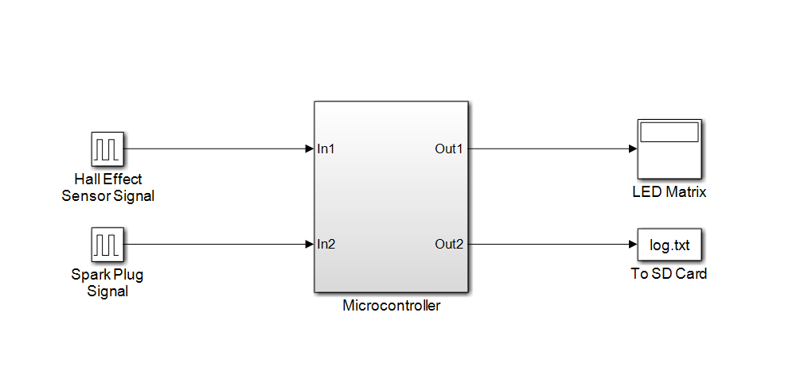Figure 5.1 – Microcontroller Overview
5.2 DESIGN METHODOLOGY
The Arduino Uno was chosen out of the possible candidates for hardware interfaces. Our group’s reasoning behind the selection was that the Arduino provided the functionality we required, and did not suffer unnecessary overhead that other similar hardware might experience. Another positive aspect about the Arduino was its modular nature. “Shields” are essentially building blocks for Arduinos, allowing multiple boards to be stacked on top one another. These shields trivialize expansion of microcontroller functionality via hardware. Since our team was tasked with making our overall project “plug-and-play” for the most general of users, the Arduino for this reason was made more attractive. Additionally, our group had a fixed budget of $200.00. The Arduino had a low price, which came into play when discussing controller options. Our LED matrix was chosen because it was much brighter than similar hardware in its price range. For a driver who needs to see the output at a glance, the LED matrix was a clear pick over its competing hardware selections. Finally, the Arduino is a well-documented and maintained microcontroller. Having an extensive library selection would ultimately reduce the time our team spent troubleshooting and testing code. Our source code is heavily influenced by Arduino libraries [5]. Online sketches for the Arduino already included mostly working code for the data logging shield [6], and the LED matrix [7].

After the Arduino was chosen as a microcontroller, the team needed a way to interpret the incoming data from the spark plug, and the Hall Effect sensor. Initially it was projected we transform the delta-like spikes into square waves via Fast Fourier Transform. However, the noise floor of the spark plug data (Fig. 5.2) was much too high to digitize the signal internally with the Arduino. As such, the signal conditioning was chosen to be external to the Arduino. The input signal from the Hall Effect sensor was close to being digital in form, so additional signal conditioning was not required.

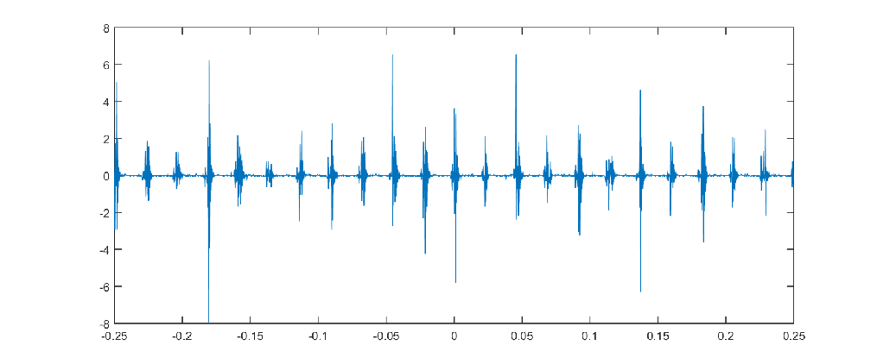
Figure 5.2 – Spark-Plug Signal Representation

The actual Arduino coding was made simpler by taking advantage of the built in libraries for SD interface and the HT1632 display. After planning which functions we would need to create, we identified the flow of logic for the code as shown (Fig. 5.3).
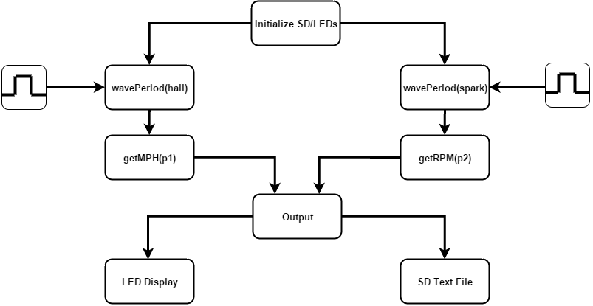
Figure 5.3 – Code Layout
For advanced troubleshooting, a “safety” was coded in where the program will end if the inputs or the SD card is disconnected mid-trial.
5.3 ANALYSIS
To prepare the actual components, all the headers and jumpers were soldered on the Arduino, data logger, and LED display. After assembling the components, three more wire leads were soldered to the Arduino I/O pins for the two inputs and ground. To simulate the incoming signals we would be processing, two waveform generators were connected to the inputs and configured for similar square waves (Fig. 5.4). The display was connected to the Arduino via colored jumpers that were later soldered in place.
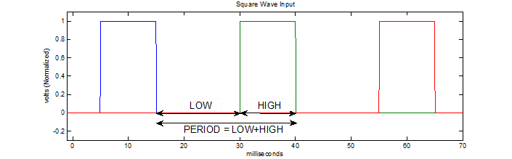
Figure 5.4 – Input Signal Waveform

Using the flowchart and existing libraries, our program was able to input both square waves successfully and calculate the periods, and then use that data to output real-time values to the LED display, while saving the tab-delimited data to a text file on the SD card for easy future analysis. The actual code is shown in (Appendix A).
The system functions properly as intended but there are many future design improvements that could be implemented into the system with relative ease (Appendix B). For example, a simple percentage bar on the two rightmost LED pixel columns could be configured into a gas gauge with a simple sensor or a timing calculation. The current numbers shown on the display are the default font from the HT1632 library, but traditional racing-dash style numbers may be easier to read for the driver. The system could be mounted in a number of places on the BAJA, from the roll cage bar mount to a sunken dash past the steering wheel. A possible issue became apparent in the display, where its half-second refresh rate may be distracting to the driver. This could be fixed by additional nested loops in the code where the screen is updated constantly (faster than the human eye can see, 60 Hz or more) whether there is a new value instance or not. There are tons of additional applications: Bluetooth integration, network monitoring and data upload via Wi-Fi or cellular, the list goes on.

6.0 CONCLUSION
The goal of our project was to design and build a system which is capable of displaying the engine RPM and vehicle speed of the SAE Baja vehicle. Individual tasks were assigned to each member, who developed an integral part of the project. Task one was to transduce the wheel rotation into the MPH of the vehicle. This was successfully completed by using a Hall Effect sensor. Task two was to transduce the firing of a spark plug which was representative of the engine RPM. Two methods were attempted, although only the first method was successful. Task three was to accept the outputs from the Hall Effect sensor and spark plug conditioning circuits into a digital readout display, as well as design a method to log the data. Our project has progressed fruitfully thus far albeit not as far as initially expected. The method of transducing the rotation of the wheel into mph of the vehicle is ready to be mounted and tested. For connection from the sensor to the Arduino module, BNC connectors would be used for easy attachment. BNC connectors would also be used for the rest of the modules for easy attachment. The first design for the circuit conditioning the spark plug pickup signal will be used for its reliability. PCB fabrication and housing will have to be done before it is ready for mounting and testing. Finally, the Arduino module is ready to be housed and mounted. The project is ready to be handed to a second senior design group to conduct improvements and final installation.

7.0 REFERENCES
- Cheng, D. (1983). Field and wave electromagnetics. Reading, Mass.: Addison Wesley.
- Mixsell, J. (2015, September 18). Conversation [Personal interview].
- Nilsson, J., & Riedel, S. (1996). Electric circuits (5th ed.). Reading, Mass.: Addison-Wesley.
- Mano, M., & Mano, M. (1984). Digital design. Englewood Cliffs, N.J.: Prentice-Hall.
- Arduino. (2015, December 8). Arduino - Libraries. Retrieved from Arduino: https://www.arduino.cc/en/Reference/Libraries
- Earl, B. (2015, December 8). Adafruit Industries. Retrieved from Adafruit: https://learn.adafruit.com/adafruit-data-logger-shield
- Fried, L. (2015, December 8). Adafruit Industries. Retrieved from Adafruit: https://learn.adafruit.com/16x24-led-matrix

8.0 APPENDIX A
8.1 ARDUINO SOURCE CODE
#include <SD.h>
#include <SPI.h>
#include "HT1632.h"

const int pinDATA = 2;
const int pinWR = 3;
const int pinCSDISP = 4; //LED Matrix Chip Select
const int pinCS2DISP = 5;
const int pinCS = 10; //SD Chip Select
const int pinCLK = 11;
const int sparkInput = 7;
const int hallInput = 8;
float t0, t1, period, p1, p2, noInput, RPM, MPH, tempRPM, tempMPH;

float radius = 0.25; //meters
int count = 0;

// use this line for single matrix
HT1632LEDMatrix matrix = HT1632LEDMatrix(pinDATA, pinWR, pinCSDISP);

File WaveAnalysis;

void setup() {
Serial.begin(115200);
pinMode(sparkInput, INPUT);
pinMode(hallInput, INPUT);

while (!Serial)
{
; // wait for serial port to connect. Needed for native USB port only
}

Serial.print("Initializing SD card...");

if (!SD.begin(pinCS))
{
Serial.println(" initialization failed!");
return;
}
Serial.println(" initialization done.");

// open the file. note that only one file can be open at a time,
// so you have to close this one before opening another.

matrix.begin(HT1632_COMMON_16NMOS);
matrix.fillScreen();
delay(500);

}

void loop()
{
matrix.clearScreen();
// draw some text!
matrix.setTextSize(1); // size 1 == 8 pixels high
matrix.setTextColor(1); // 'lit' LEDs

WaveAnalysis = SD.open("wave.txt", FILE_WRITE);

if(count == 0) //sets up tabs and data columns
{
WaveAnalysis.print("\n");
WaveAnalysis.println("NEW DATA:");
WaveAnalysis.print("\n");
Serial.print("\n");
Serial.print("NEW DATA:");
Serial.print("\n");
Serial.print("\n");

WaveAnalysis.print("PERIOD 1");
Serial.print("PERIOD 1");
WaveAnalysis.print("\t");
Serial.print("\t");

WaveAnalysis.print("PERIOD 2");
Serial.print("PERIOD 2");
WaveAnalysis.print("\t");
WaveAnalysis.print("\t");
Serial.print("\t");
Serial.print("\t");

WaveAnalysis.print("MPH");
Serial.print("MPH");
WaveAnalysis.print("\t");
WaveAnalysis.print("\t");
Serial.print("\t");
Serial.print("\t");

WaveAnalysis.print("RPM");
Serial.print("RPM");
WaveAnalysis.print("\t");
WaveAnalysis.print("\t");
Serial.print("\t");
Serial.print("\t");

Serial.print("\n");
WaveAnalysis.print("\n");
count++;
}

if (WaveAnalysis)
{
p1 = wavePeriod(sparkInput);
p2 = wavePeriod(hallInput);

Serial.print(p2);
WaveAnalysis.print(p2);
WaveAnalysis.print("\t");
WaveAnalysis.print("\t");
Serial.print("\t");
Serial.print("\t");

Serial.print(p1);
WaveAnalysis.print(p1);
WaveAnalysis.print("\t");
WaveAnalysis.print("\t");
Serial.print("\t");
Serial.print("\t");

tempMPH = getMPH(p2); //change period
matrix.setCursor(0, 0); // start at top left, with one pixel of spacing
matrix.print(tempMPH);
Serial.print(tempMPH);
WaveAnalysis.print(tempMPH);
WaveAnalysis.print("\t");
WaveAnalysis.print("\t");
Serial.print("\t");
Serial.print("\t");

tempRPM = getRPM(p1);
matrix.setCursor(0, 8); // next line, 8 pixels down
matrix.print(tempRPM);
WaveAnalysis.print(tempRPM);
Serial.print(tempRPM);

matrix.writeScreen();

Serial.print("\n");
WaveAnalysis.print("\n");

delay(700);

WaveAnalysis.close();
} else
{
// if no data is being input, then exit program
Serial.println("error opening test.txt");
exit(0);
}
}

float wavePeriod(const int input)
{
t0 = pulseIn(input, LOW); //in microseconds
t1 = pulseIn(input, HIGH);
period = t0 + t1;
return period;
}

float getRPM(float period1)
{
RPM = (1/period1)*60*10000; //1000 or 10000?
return RPM;
}

float getMPH(float period2)
{
MPH = .621371*(36*3.14159*radius)/(5*period2)*100000; //change period
//MPH = (1/(period2*10000))*(60000)*(2*3.14159*radius*60/5280);
return MPH;
}

9.0 APPENDIX B
9.1 FUTURE ARDUINO PSEUDOCODE

//For a gas gauge:

var a = get (time from RTC); //at beginning of data acquisition

var b = get (time from RTC); //at end of data acquisition

//Next run time:

percent =a/b;

gas_left = (1-percent)*100;

print.gas_left;

//To smooth out data collected:

var arr[3];
var mu, oldmu;

//get old, current, and new period
arr[0] = old.period;
arr[1] = period;
arr[2] = new.period;

//calculate period via moving average
for {int i = 0, i <= 2, i++}
{
mu += arr[i];
}
//get new mu
var get.mu (var a, var b)
{
mu = (b - a)/length(arr); //average
return mu;
}

