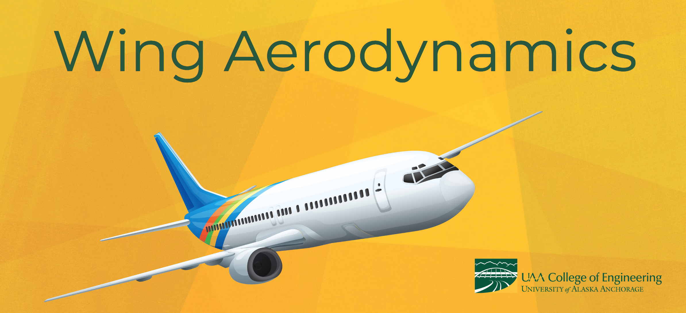

**Time:** 1 day (6 hours)

**Class Size:** 32 students, paired into 8 groups of 4 for activities

**Lesson Overview & Objectives:**

|  |  |  |  |
| --- | --- | --- | --- |
| **Lesson** | | **Objective** | **Time** |
| 1 | Explore Forces of Flight | * Students will explore the forces of flight through movement and hands-on activities | 1 hour |
| 2 | Bernoulli Principle | * Students will participate in multiple demonstrations and activities to learn about the Bernoulli Principle. * Students will be able to explain how the Bernoulli Principle applies to the movement of objects and how it relates to flight. * Students will understand the effect of air flowing over a curved surface. | 1 hour |
| 3 | Making/Testing Airfoils | * Students build and test their own airfoils in a wind tunnel. * Students will understand the relationship of airfoil design and angle of attack on lift and drag. | 2-4 hours |

**Materials Needed:**

|  |  |  |  |
| --- | --- | --- | --- |
| **Exploration Time** | | **Building/Testing Airfoils** | |
| Large flat board (IE: foam core board) | 1 | Airfoil Templates | 32 |
| Giant airfoil | 1 | Wooden Skewers (3/airfoil/group) | 27 |
| **Bernoulli Masks** | | Elmer’s Glue | 8 |
| Paper Plates | 8 | Wind tunnel | 1 |
| Strips pink/red copy paper (1½”x8”) | 8 | Box fan | 1 |
| Sets of Markers | 8 | Scale | 1 |
| **Bernoulli Masks** | | Cardboard or foam board  (3 sheets per group, minimum of 7” x 8”) | 24 |
| *Leaf blower | 1 | Heavy paper (3 sheets per group) | 24 |
| *12” dowl (handle for TP) | 1 | **General Materials** | |
| *Toilet Paper Roll | 1 | Masking Tape Rolls | 2 |
| *Hair dryer | 1 | Google Slides: Wing Aerodynamics | 1 |
| *Ping Pong ball | 1 | Scissors | 8 |
| *Small beach ball(s) | 1-3 |  |  |
| *Sound Tube | 1 |  |  |
| *Bernoulli bags/trash bag | 2 |  |  |
| *Balloons | 2 |  |  |
| *Strings (2 feet) | 2 |  |  |
| *Straw | 1 |  |  |

**\*** Indicates supplies used for the Bernoulli Principle demonstrations - you may choose to incorporate as many or as few of these demos as you’d like.

**Key Vocabulary:**

|  |  |  |
| --- | --- | --- |
| * Force * Aerodynamics * Lift | * Drag * Weight * The Bernoulli Principle | * Low Pressure * High Pressure * Flow * Angle of attack |

**Video Resources:**

* How Do Planes Fly? National Geographic (<https://www.youtube.com/watch?v=QggNdV9TmvA>) Upbeat 1 ½ minute overview of different types of airplanes and a couple cool stats
* The Aerodynamics of Flight (<https://www.youtube.com/watch?v=5ltjFEei3AI>)  
  7-min video clearly explaining aerodynamic, more in tune for older students

**Extension Activities:**

* Make a paper whirleybird [www.scientificamerican.com/article/make-a-whirlybird-from-paper](https://www.scientificamerican.com/article/make-a-whirlybird-from-paper/)
* Online flight simulator games: [http://www.flightarcade.com](http://www.flightarcade.com/)
* Flying Paper Birds: [projectbeak.org/teacher/pdf/adaptations_wings_and_flight_paper_airplances.pdf](http://projectbeak.org/teacher/pdf/adaptations_wings_and_flight_paper_airplances.pdf)
* Wind dispersed seed activity (ASD 3rd grade curriculum)
* Build and fly kites
* Build Pinwheels and play with them

Lesson 1: Explore Forces of Flight

|  |  |
| --- | --- |
| Time Needed: | 1 hour |
| Objectives: | * Students will explore the forces of flight through movement and hands-on activities |
| Setup: | **Exploration:** takes place outside or in a gym, with lots of space to run  **Instruction:** relies on projector, videos, and presentations and should take place in a classroom. |

**Explore Forces of Flight (30 min)**

Assign students to groups, and assemble exploration area outside or in a gym. Before exploration activities begin, explain to students that we are going to explore dynamics of movement through air today, and the many different forces that interact when objects are moving through fluids and gases.

Exploration tasks for students:

* Run as fast as you can without holding anything
* Run as fast as you can while holding a piece of foam board flat above your head
* Run as fast as you can while holding a giant airfoil over the top of your head (allow students turns running with the airfoil)

**Discussion Questions:**

* *What did you notice when running with the board? What did you feel?*
* *Would you say it was an easier or more difficult than regular running?*
* *Why do you think that is?*
* *Would you want to run in a giant windstorm like that?*
* *What did you notice when running with the airfoil? What did you feel?*
* *Why do you think that is?*
* *How do you think it would feel if you ran in a giant windstorm with an airfoil?*
* *What kept you moving forward in both activities? (feet running)*
* *What kept you from taking off into the sky? (weight, gravity pulling on them)*

Introduce students to concepts of **lift**, **drag**, **weight**, and **thrust** and that these are the forces at work on objects in flight, such as birds and airplanes. Today, we’re going to learn about **aerodynamics** of wings.

**Lecture-Forces of Flight:**

Use the Google Slides and/or the The Aerodynamics of Flight video (<https://www.youtube.com/watch?v=5ltjFEei3AI>) to further explain the concepts of lift, weight, thrust, and drag.

Lesson 2: The Bernoulli Principle

|  |  |
| --- | --- |
| Time Needed: | 1 hour |
| Objectives: | * Students will participate in multiple demonstrations and activities to learn about the Bernoulli Principle. * Students will be able to explain how the Bernoulli Principle applies to the movement of objects and how it relates to flight. * Students will understand the effect of air flowing over a curved surface. |
| Setup: | This lesson contains build activities thatshould take place in a classroom with ample tabletop work space. |

**Bernoulli Masks**

Hand out Bernounlli mask instructions and materials to small groups. Aftwards, discuss:

* *Who thought the tongue was going to push away from the blowing air? Who thought it would move toward the flowing air?*
* *Why do you think the tongue moved toward the blowing air instead of away?*

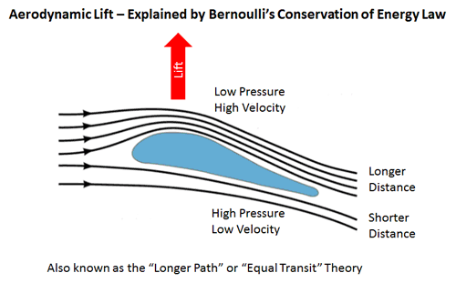

**Explanation**

Explain to students the basics of Bernoulli’s Principle, including key points that:

* Fast moving air: low pressure
* Slow moving air: high pressure
* Air moving over top of airfoil has further to travel, and moves faster
* Air moving over bottom of airfoil has shorter to travel and moves slower
* This creates low pressure above the airfoil and high pressure below, resulting in lift

This video provides a great visual of smoke in a wind tunnel going over an airfoil (recommend muting, as the narration is complex/might confuse students) <https://www.youtube.com/watch?v=UqBmdZ-BNig>

**Other Bernoulli Demonstrations**

Use any combination of the following demonstrations to further dazzle students, connecting the objects’ behaviors to concepts of high and low pressure air.

* Paper and Toilet paper (<https://www.youtube.com/watch?v=025lsG3VHKM>)
* Floating Ball (<https://youtu.be/sIrJOrTAJjg?list=PLCvVBOK6lIHvHf2xqX0p7BMqf32oJsuP9>)
* Sound Tube (<https://youtu.be/RQbQguLNtC8?list=PLCvVBOK6lIHvHf2xqX0p7BMqf32oJsuP9>)
* Bags (<https://youtu.be/LPpbiG-jTWI?list=PLCvVBOK6lIHvHf2xqX0p7BMqf32oJsuP9>)
* Balloons (<https://www.youtube.com/watch?v=c_DUlhl0oxk>)

# Lesson 3: Making and Testing Airfoils

|  |  |
| --- | --- |
| Time Needed: | 2-4 hours |
| Objectives: | * Students build and test their own airfoils in a wind tunnel. * Students will understand the relationship of airfoil design and angle of attack on lift and drag. |
| Setup: | **Build Time:** This lesson contains build activities thatshould take place in a classroom with ample tabletop work space.  **Testing Jig:** Set up air tunnel with testing jig and scale in a designated testing area of the instruction space. |

**Build Airfoils**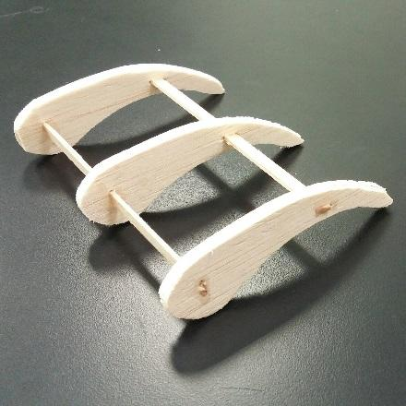

Students follow these steps to build three airfoils:

1. Use the printed templates to cut 3 airfoils from the cardboard/foam board.
2. Use several sticks to connect these 3 airfoils together to form a wing.
3. Wrap paper around the surface of the wing.
4. Repeat for the other 2 wings. These 3 wings will be used in the wind tunnel.

**Testing: Lift measurement**Students follow these steps to test their airfoils and record results in airfoil data collection sheets.

1. Place the fan at the flow intake facing inward.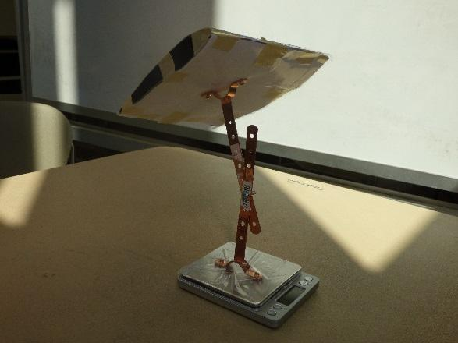
2. Use a wing made earlier, tape it on the holder.
3. Tape the holder on the scale. Place the scale in the center of the box so the digital read-out is facing the viewing window.
4. Record the weight of wing (with the holder).
5. Turn on the fan to the highest speed. Record the weight of wing again. The difference is the lift generated on the wing.
6. Repeat the measurements twice and calculate the average lift.
7. Adjust the angle of attack. Repeat steps 3-6.
8. Repeat steps 3-7 for all the air foils you made.
9. Enter the data into Excel and plot the lift v.s. angle of attack for each airfoil and the airplane.
10. Use one wing to measure the lift at different wind speed. Tape the wing on the stand and place it at 20o angle of attack. Measure the lift at 3 different fan speeds. Repeat for 40o and 60o angle of attack.

**Discussion Questions:**

* *What patterns did you find in your data?*
* *Which airfoil design created the most lift?*
* *How did the angle of attack impact lift?*
* *What force was at work that we could not measure in this experiment? (drag)*
* *How do you think drag impacted the designs we tested?*
* *How does this relate to birds and airplanes?*