Bernoulli Mask Instructions
Reader | Reads directions aloud to group step by step
Artist | Draws all lines, markings, and colors
Machinist | Performs all cutting and taping
Model | Wears the bag and conducts final test

STEP 1  Place a large paper grocery bag over the model’s head. The artist use a marker to carefully draw small dots where the eyes, nose, and mouth of the model are located. DO NOT PRESS TOO HARD! | 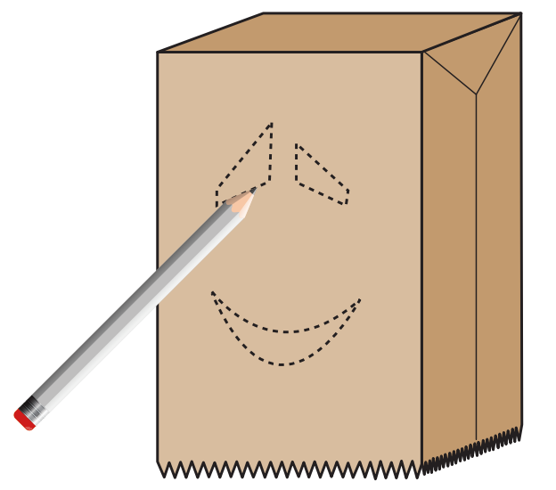
STEP 2  Remove the bag from the model’s head. The artist draws a face around the marks made in step 1. | 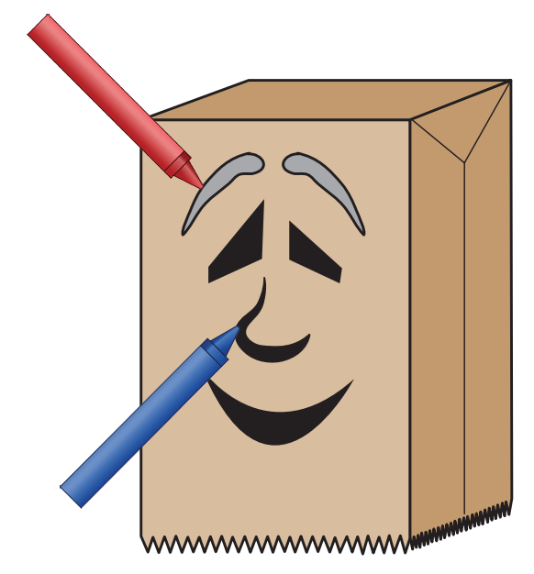
STEP 3  Now it’s time for the machinist to cut out holes (approximately 1 inch in diameter) for each eye. Next, cut a mouth-shaped hole approximately 2 inches in height at the widest point, the middle, of the mouth. | 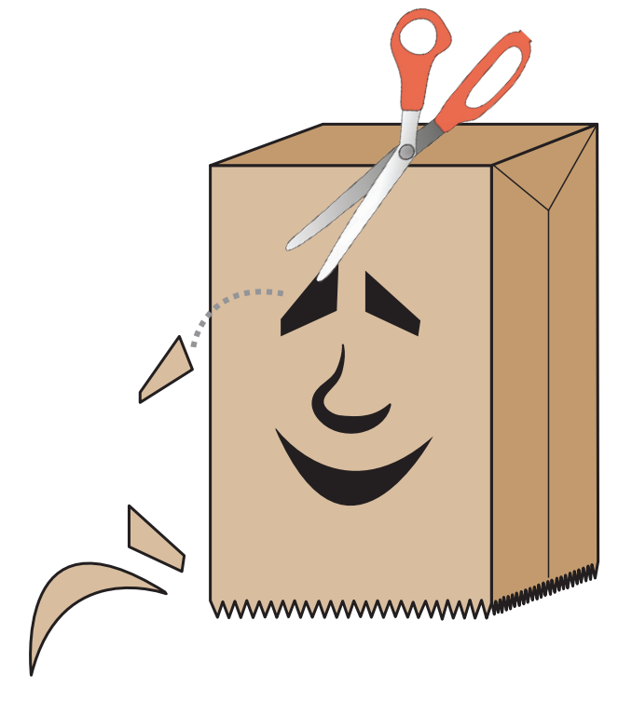
STEP 4  Fold down one end of the tongue to create a ¼ inch tab. Use masking tape to attach the tab to the inside of the bag along the lower middle edge of the mouth. The rest of the tongue should be hanging out of the mouth. | 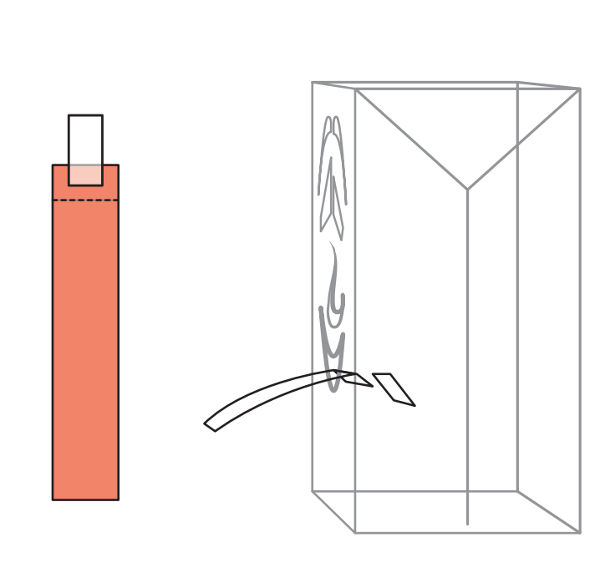
STEP 5  Make a hypothesis: before trying the mask on, let’s make a hypothesis! What do you think will happen to the tongue when the model blows steadily out from the mouth? | 
STEP 6  Place the bag over the model’s head and watch what happens when they blow through the mouth hole with an even stream of air. What happens to the tongue? | 