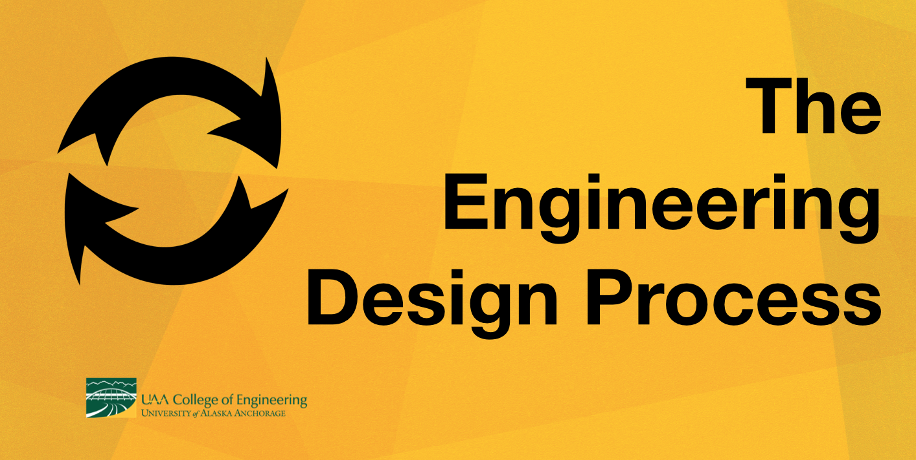

**Time Needed:** 1-1.5 hours

**Class Size:** 30 students, paired into 8 groups of 4 for activities

**Objective:**

Students will follow the engineering process to research, design, build, test, and redesign towers made of spaghetti and marshmallows.

**Materials Needed:**

|  |  |
| --- | --- |
| **Material** | **Quantity** |
| Spaghetti Noodles | 320 |
| Mini rubber bands | 16 |
| Mini-Marshmallows | 480 |
| Snack sized Ziplock bags | 16 |
| Paper Plates | 8 |
| Handout: Spaghetti Tower Challenge | 8 |
| Handout: Inspiration from real towers | 8 |
| Handout: Examples | 8 |
| Research Worksheet | 8 |
| Scratch Paper | 32 |
| Pen/pencils | 32 |

# **Setup:**

Material Management Tip: use mini rubber bands to bundle 20 uncooked spaghetti noodles together and snack bags to count out 30 marshmallows in advance. Plan for 2 sets of materials for each group.

**Introduction (~10 min)**

Ask students:

* *What is the tallest building you’ve ever seen?*
* *How do you think tall buildings stay up?*
* *Who do you think designed those buildings?*
* *How do you think engineers go about designing and planning these buildings?*

Explain to students that engineers are among the many professionals involved designing and building structures like towers and buildings. Today, we are going to pretend we’re structural engineers and design and build some of our own towers.

**Present Challenge (~5 min)**

Break students up into groups of 4. Distribute Spaghetti tower challenge sheets and review them with students. Answer any questions they may have about the challenge and check for understanding.

**Inspiration (~10 min)**

Explain to students that, before they begin their challenge, you would like them to get some inspiration and ideas from professionally designed, successful buildings and towers.

Distribute:

* Handout: Inspiration from real towers
* Handout: Examples
* Research worksheet

In groups, students review the provided images and make observations. Distribute 1 noodle and 1 marshmallow to each student. Students make observations about the properties of each material. When groups are finished, ask 3-5 volunteers to share their observations with the group.

**Brainstorm (~5)**

Distribute scratch paper to students and tell them it is time to brainstorm ideas in drawings and/or writing ideas out. When in brainstorm mode, groups often face two common obstacles, which should be addressed before groups begin brainstorming.

1. When brainstorming, there is **no such thing as a bad idea!** Brainstorming should be a brain-dump stage in which all ideas get jotted down or sketched. We are always tempted to allow our inner criticism to begin determining good or bad ideas, or start judging others’ ideas. However, this tends to block us from letting new ideas flow. **Brainstorming should be a safe space for any idea.**
2. Many students will want to settle on their design immediately. They will land on an idea and decide, this is the one! It’s important that brainstorming mode be allowed to stretch on beyond that initial “good idea.” **You never know when an even more unique, stronger, better idea is going to strike!** Encourage students to continue brainstorming ideas and to refrain from any decision making during this step.

**Making a Decision (~5 min)**

Ask students:

* *When structural engineers are deciding on which idea to design and build, what factors do you think they use to make that decision? (Overall strength, cost of materials, cost of project, time to build, aesthetic appeal, etc.)*
* *What factors do you think we should take into consideration when choosing which idea to design and build? (number of materials, strength/properties of materials, how long to build)*

In groups, allow students time to discuss their ideas and choose which one to proceed with.

**Final Planning (~5 min)**

Before getting started with construction, groups should develop their chosen ideas a couple extra steps: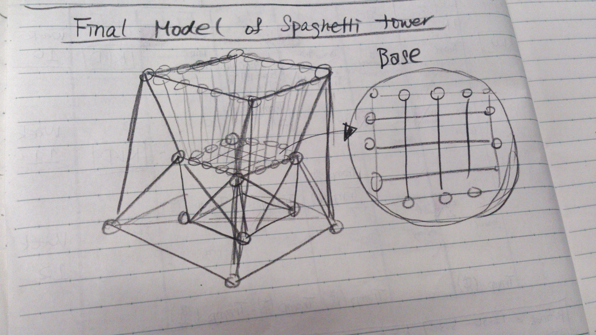

* Drawing: should be more detail and include indications of joints and marshmallows.
* Labels: like engineers, encourage students to label their plans to make sure everyone on their team is on the same page. Include measurements when possible/if age appropriate.

**Building (~10 min)**

Before distributing materials, it’s helpful to establish appropriate use of those materials. IE: towers must remain on the plates, marshmallows are not for eating, marshmallows should maintain their form (not be squished into cream), etc.

Distribute materials and allow groups to work. Enforce a strict countdown and hands-off at the five-minute mark, or otherwise chosen amount of time.

**Group Discussion (~5 min)**

Students leave towers in their work areas, and come together for discussion:

* *What went well?*
* *What did not go so well?*
* *What challenges did your group face while working?*
* *Did anyone change their design while building? Why did your design change?*
* *Now that you’ve worked with the materials, do you have ideas on how to improve the design?*

Explain to students that they will now have the opportunity to make some improvements to their designs with 5 minutes of extra build time. They may choose to start over or modify one part of the tower. Allow time for groups to discuss their strategy.

**Redesign/Extra Build Time (~10 min)**

Students may request a fresh set of materials if they would like to try an entire redesign. Allow groups the same amount of time as their initial build session, and once again enforce a strict countdown.

Allow a showcase of final tower designs afterwards, appreciating unique designs and standing structures.

**Conclusion (~10)**

Ask students to reflect on the steps we took today and share what they recall from each of those steps. What was the value of each of these steps?

As students hit each step of the engineering design process, identify what that step’s name is and define it.

|  |  |  |
| --- | --- | --- |
| **Engr Process** | **Definition** | **What we did** |
| 1. Ask | Identify the problem, what constraints, requirements, and parameters exist | We looked over the rules to better understand what the challenge was. |
| 2. Research | Draw inspiration from ideas that others have already come up with. | We looked at pictures of famous towers. |
| 3. Imagine | Brainstorm a variety of ideas. | We came up with many ideas. |
| 4. Plan | Choose an idea & plan it out in detail. | We chose an idea and made detailed drawings. |
| 5. Create | Build. | We built our towers. |
| 6. Test | Test the design, make observation of its performance. Collect data to improve desig. | We saw if our towers could stand and talked about what worked or didn’t work. |
| 7. Improve | Redesign based on performance during test, then go back to testing. Continue testing and redesigning many times until you have a final working product. | We redesigned and improved our first design. |
| 8. Present | Present our design to a group. In the real world, this might be pitching a product to funders, presenting research to a group, etc. | We had a final showcase to show each other our tower designs. |

Explain to students that this is the process engineers use while creating new solutions to problems. However, the process is also helpful in many other areas of life!

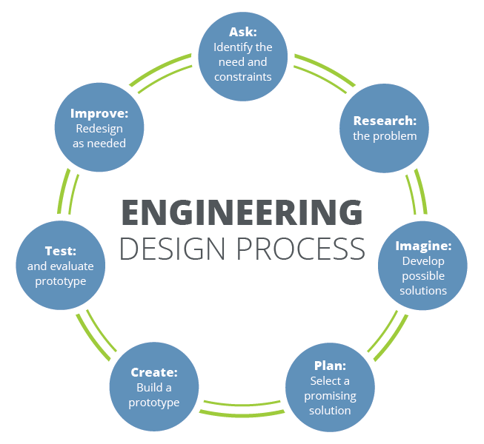

**Extensions/Additional Resources:**

* [The Engineering Process: Crash Course Kids #12.2](https://youtu.be/zADj0k0waFY) this 5 minute video does a really nice job providing an overview of the engineering process with examples from real life innovators.
* Classroom Display: Students assist in creating a classroom display of the design process. Each group takes one step of the process and creates a poster.