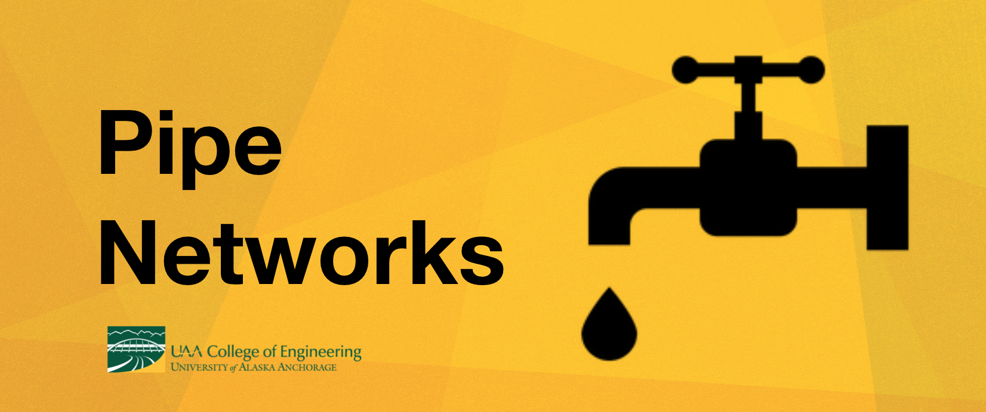
Time Needed: | 1 day (6 hours)
Class Size: | 30 students, paired into 10 groups of 3 for activities
Summary: | Students will experiment with building pipe networks out of various diameters of piping and determine how pipe size, bends, splits, adaptors, distance and pressure head impact the flow of water.
Objectives: | - Students will learn how to design, build, and manage water as it is flowing in pipes.  - Students will engage in an inquiry-based engineering project.
Setup: | Lecture/Discussion: Portions of this lesson utilize a Google presentation and YouTube videos. A classroom with internet/computer/projector should work well for these sessions.  Exploration Stations: It’s highly recommended that these stations be set up outside, to prevent indoors water messes. The stations will require a raised surface for the trash cans to sit on. Each station should be equipped with materials for 2-3 groups of students at a time. 1-3 large trash cans can be filled with water ahead of time to reduce congestion at water fill stations.  - Station 1: Pipe Diameter  - 3 Black trash cans with multiple valve sizes  - Stock with a variety of pvc pipe segments of the same length but different diameters  - Station 2: Pipe Length  - 3 Blue trash cans with ½ inch valve  - Stock with ½ PVC pipes of various lengths  - Station 3: Bends in Network  - 3 blue trash cans with ½ inch valve  - Various segments of 1 inch PVC  - Long segments of 1 inch PVC pipes  - Eighteen ½ inch elbows  Competition Activity: Should also be set up outside, and reuses all the components from the exploration stations. Students can choose components and bring them back to their own work stations.

Materials Needed:
Material | Quantity
Blue trash cans with single valve at base | 9
Black trash cans with three sizes of valves at base | 3
2-gallon buckets
5-gallon buckets
Various pipes, connectors, elbows, U’s, and adaptors in ¼”, ½”, 1” diameters | Many
Pipe Network Station Instructions | 8
Hose with water access | 1
Large trash can water reservoirs | 1-3
Raised surfaces for trash cans (IE: tables) to accommodate 8 groups | 8
Soda bottle with 3 holes (head demo) | 1

Key Vocabulary:
- Variable  - Diameter  - Length | - Pressure  - Head  - Flow Rate  - Gravity

INTRODUCTION (15 MIN)
PowerPoint Slide | Instruction/Discussion Questions
What do Engineers do? | What do engineers do?  What is engineering?  (Solving problem using science and mathematics)
Various Engineering Careers (3-12) | What are some of the many different types of engineers?  - Civil: roads and utilities  - Structural: buildings and bridges  - Mechanical: heating, ventilation, moving parts  - Environmental: water and pollution  - Computer science: hardware and software programming and technology  - Electrical: electricity  - Geotechnical: ground stability  - Chemical: chemistry and solvents  - Aerospace: space!  - Water Engineering: Drinking water; wastewater; ground water; pollution, natural resources
Water Engineering (12) | How do you use water in your daily life?  What do we need to be able to do with water?
Pipe Networks (13) | What kinds of things are carried by pipes?  (Drinking water, sewer, hot and cold water in the house, oil and natural gas, blood, engine cooling water, boiler)  Why do we need to move water around?
Pipe Systems (14) | Typical pipe system has different diameter pipes connected by fittings and elbows to route flow, valves to control flow rate, and pumps to pressurize the fluid  Algebra Example: 1 million MILES + 13,200miles/year of new pipes in the US for 154,000 finished water storage facilities (2003) – Calculate how many miles exist in 2019?

Video Extensions:
Video
What is a Watershed? | 1 min animated video overview of watersheds
An animation of the 1854 cholera outbreak in Soho | 4 min annotated time-lapse displaying 1854 cholera cases on a map, highlighting John Snow’s discovery of source as the Broad Street pump
“England: The Broad Street Pump - You Know Nothing, John Snow - Extra History - #1” | 7 min animated video telling the story of John Snow’s life leading up to his discovery of Cholera being carried by water and stopping the 1854 outbreak

EXPLORATION STATIONS (1 HR)
Students will explore 3 different variables through 15 minutes sessions at 3 different stations. Stations should be equipped with materials to support 3 groups at a time. Give students exploration instruction/data collection sheets. Students should log hypotheses before exploring at each station.

- Station 1: Pipe Diameter
- Station 2: Pipe Length
- Station 3: Bends in Network

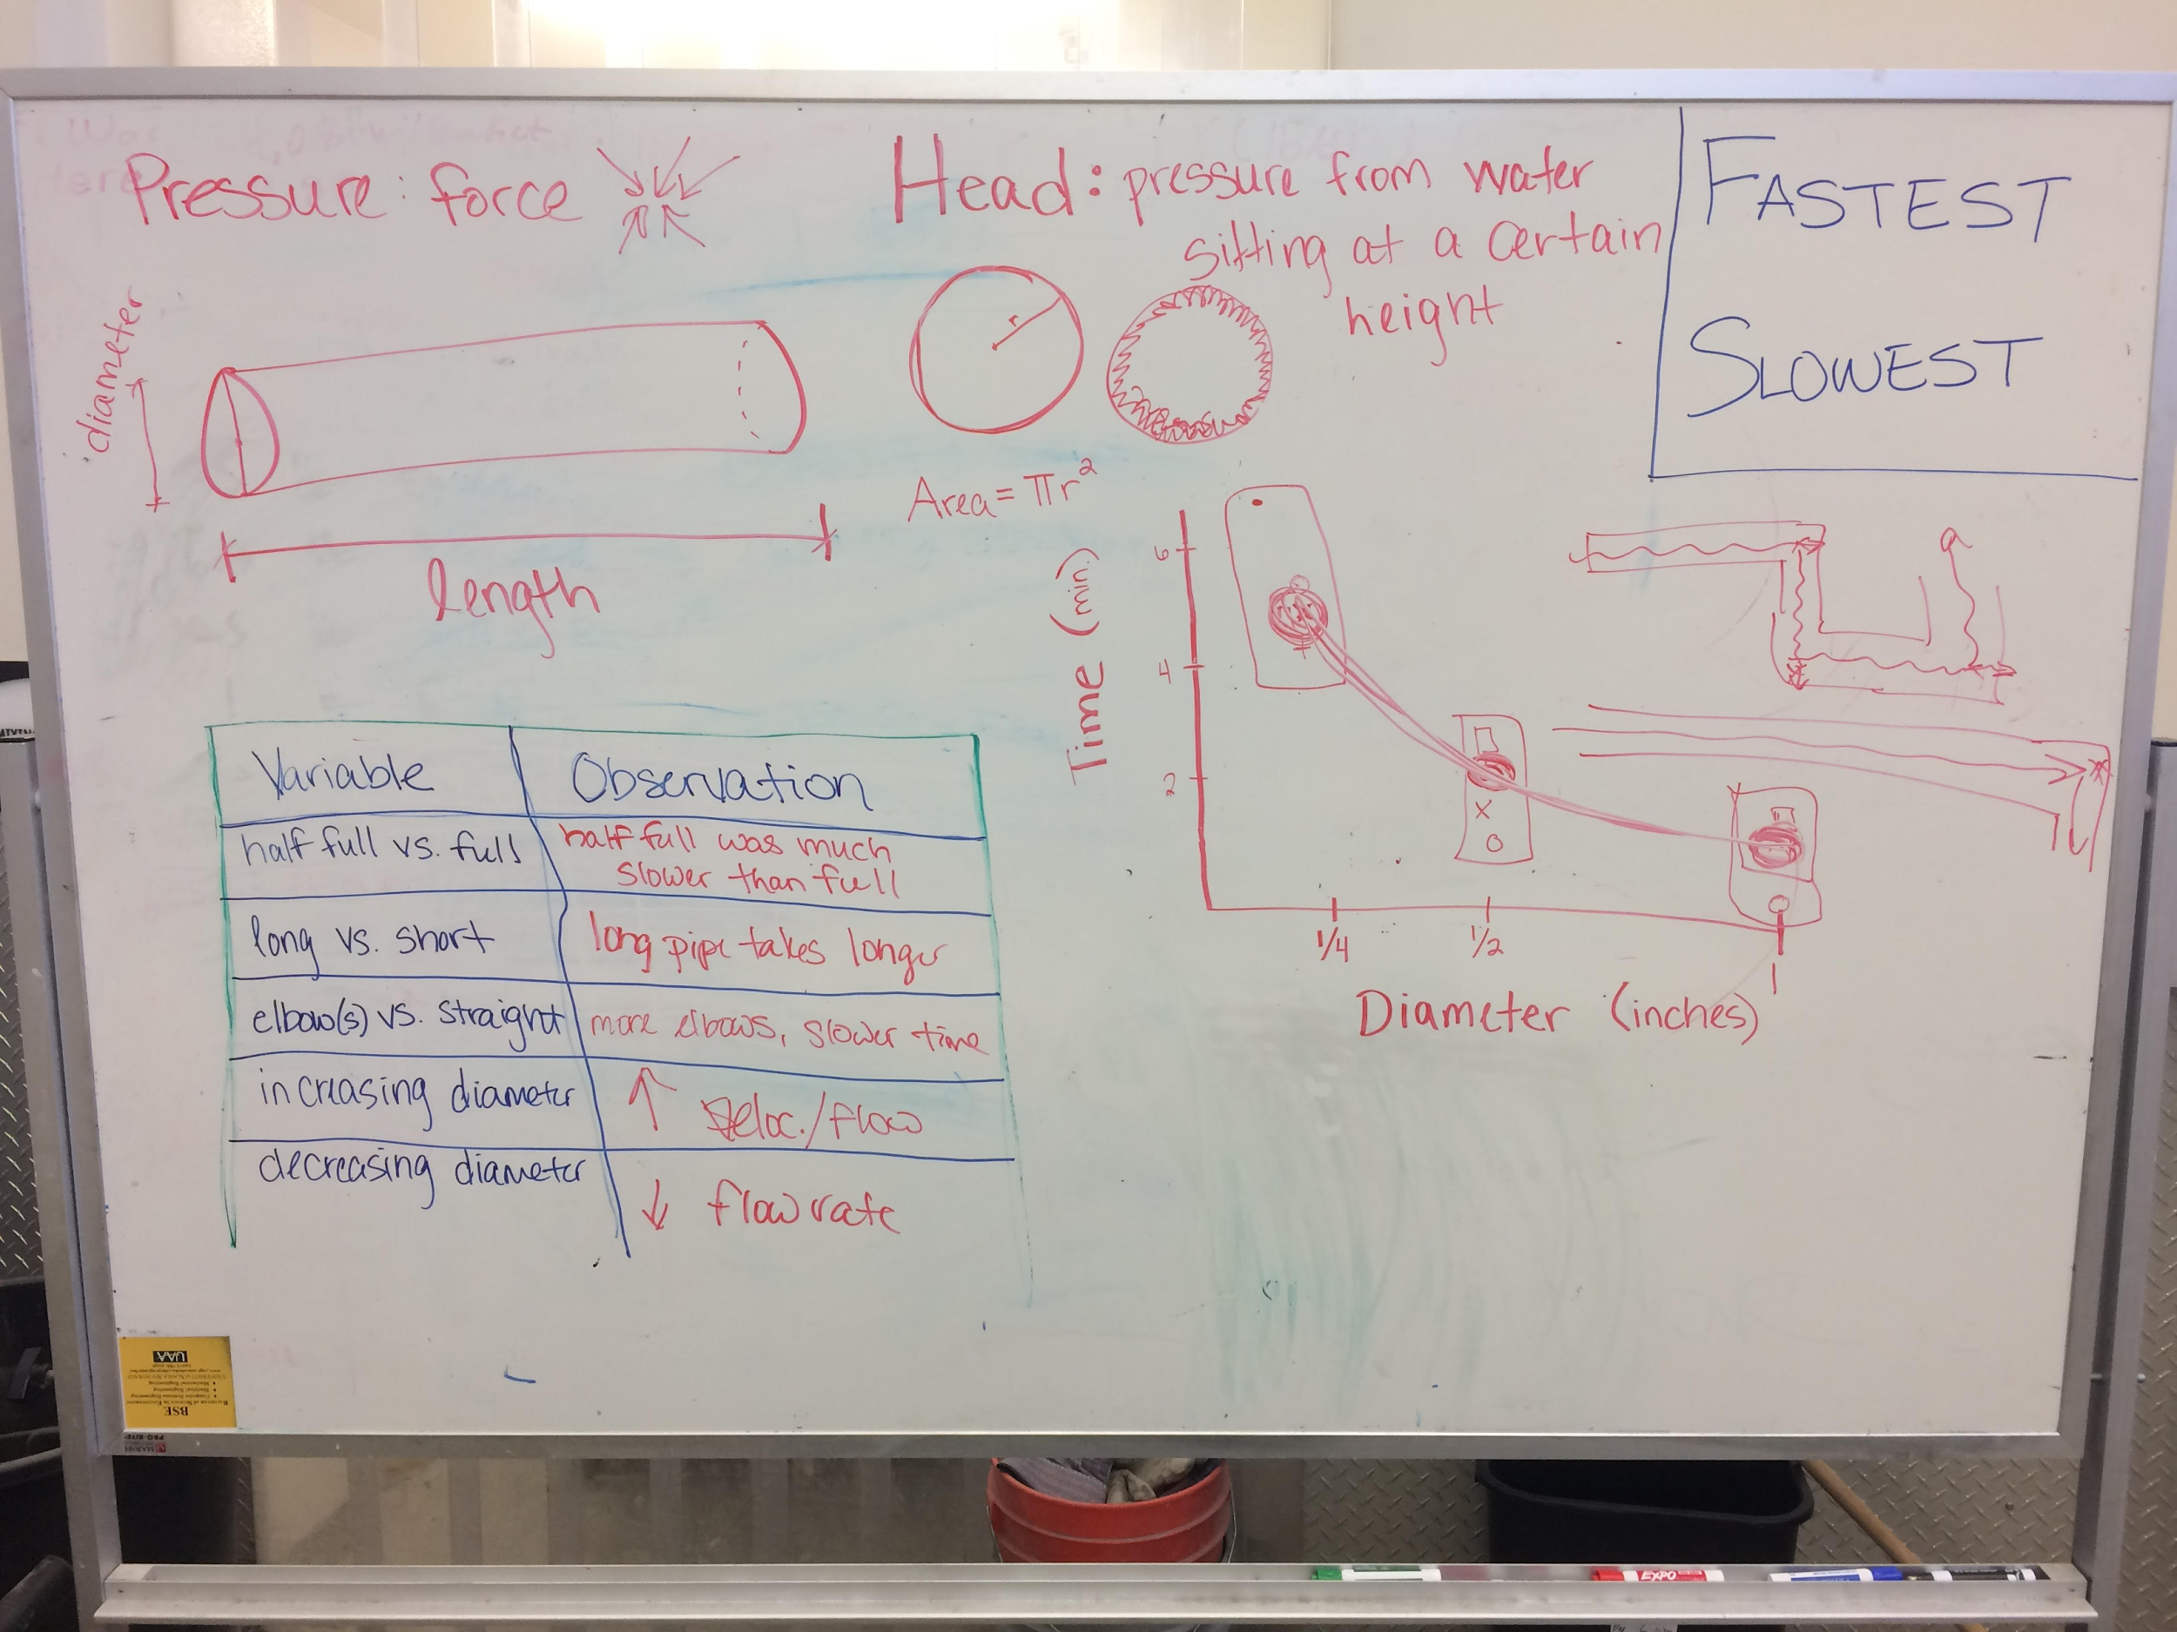
Upon completion of exploration stations, whole class shares observations and data:

- Share data with the other groups and report out. Are datasets the exact same? What could be causing differences?
- Create a graph of the data (independent variable = diameter, dependent variable = time to fill container).
- Were groups’ hypotheses correct?

DEMONSTRATION (20 MIN)
Use the provided soda bottle to demonstrate the concept of head.

Video demonstration options include:
- Soda bottle pressure head (depth of water column) – water can exert pressure down and out DEMO and/or https://www.youtube.com/watch?v=2tBWfqKA0Tk
- Guy in Pool w/ Water Pressure: https://www.youtube.com/watch?v=jS3OlpHCRLk

LECTURE (15 MIN)
Some cool water videos:
- Cartoon What happens at the bottom of the Marianas Trench: https://www.youtube.com/watch?v=WqMID7Y3Txc
- Cool creatures in the Marianas Trench: https://www.youtube.com/watch?v=VlGfibiX4Wk
- Frozen Bursting Water Pipe: https://www.youtube.com/watch?v=HFMJp2xaKCk
- Cool water/sound experiment: https://www.youtube.com/watch?v=uENITui5_jU
- Honeybucket Blues: https://www.youtube.com/watch?v=8SyT-XeDoK8
- We Are Still Waiting (rural AK honeybucket documentary) https://www.youtube.com/watch?v=CeMiCGa3Ync

Real World Examples of pipe flow variation:
- Fire hydrant: lots of water, really fast flow
- House: moderate water, moderate flow, high pressure
- Entire water distribution system (Transmission mains -> distribution mains -> service lines -> premise plumbing)
- Pipes have to deliver quantity required, resist internal and external forces, be durable and have a long life (branch or grid/loop https://www.nap.edu/read/11728/chapter/3)

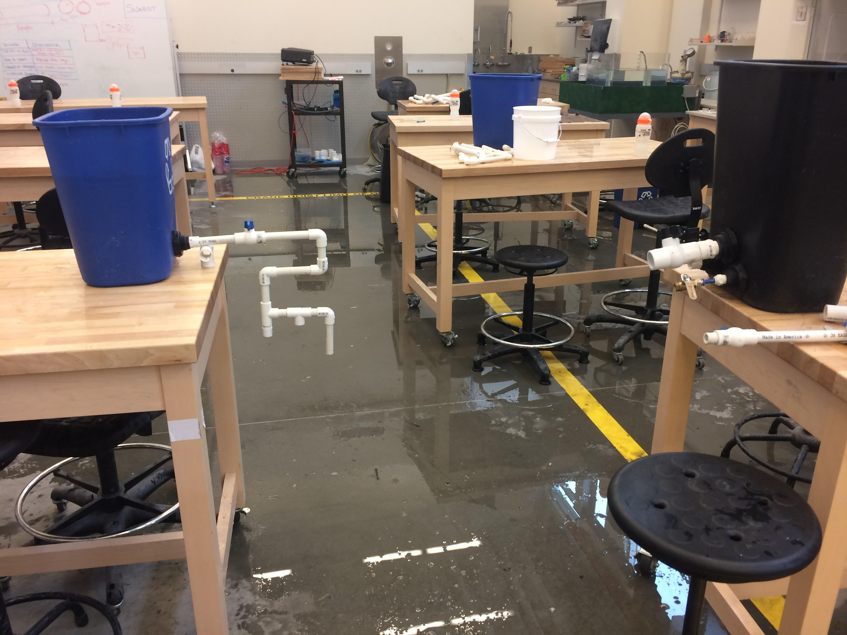
PIPE CHALLENGE (1.5 HRS)
Present students with the Pipe Network Challenge:

- Fill a 4-gallon bucket in exactly 2 minutes and 20 seconds without touching it.
- Extra: simultaneously fill two 4-gallon buckets from two different sources at the same distance in the exact same amount of time. Start with different initial piping sizes.

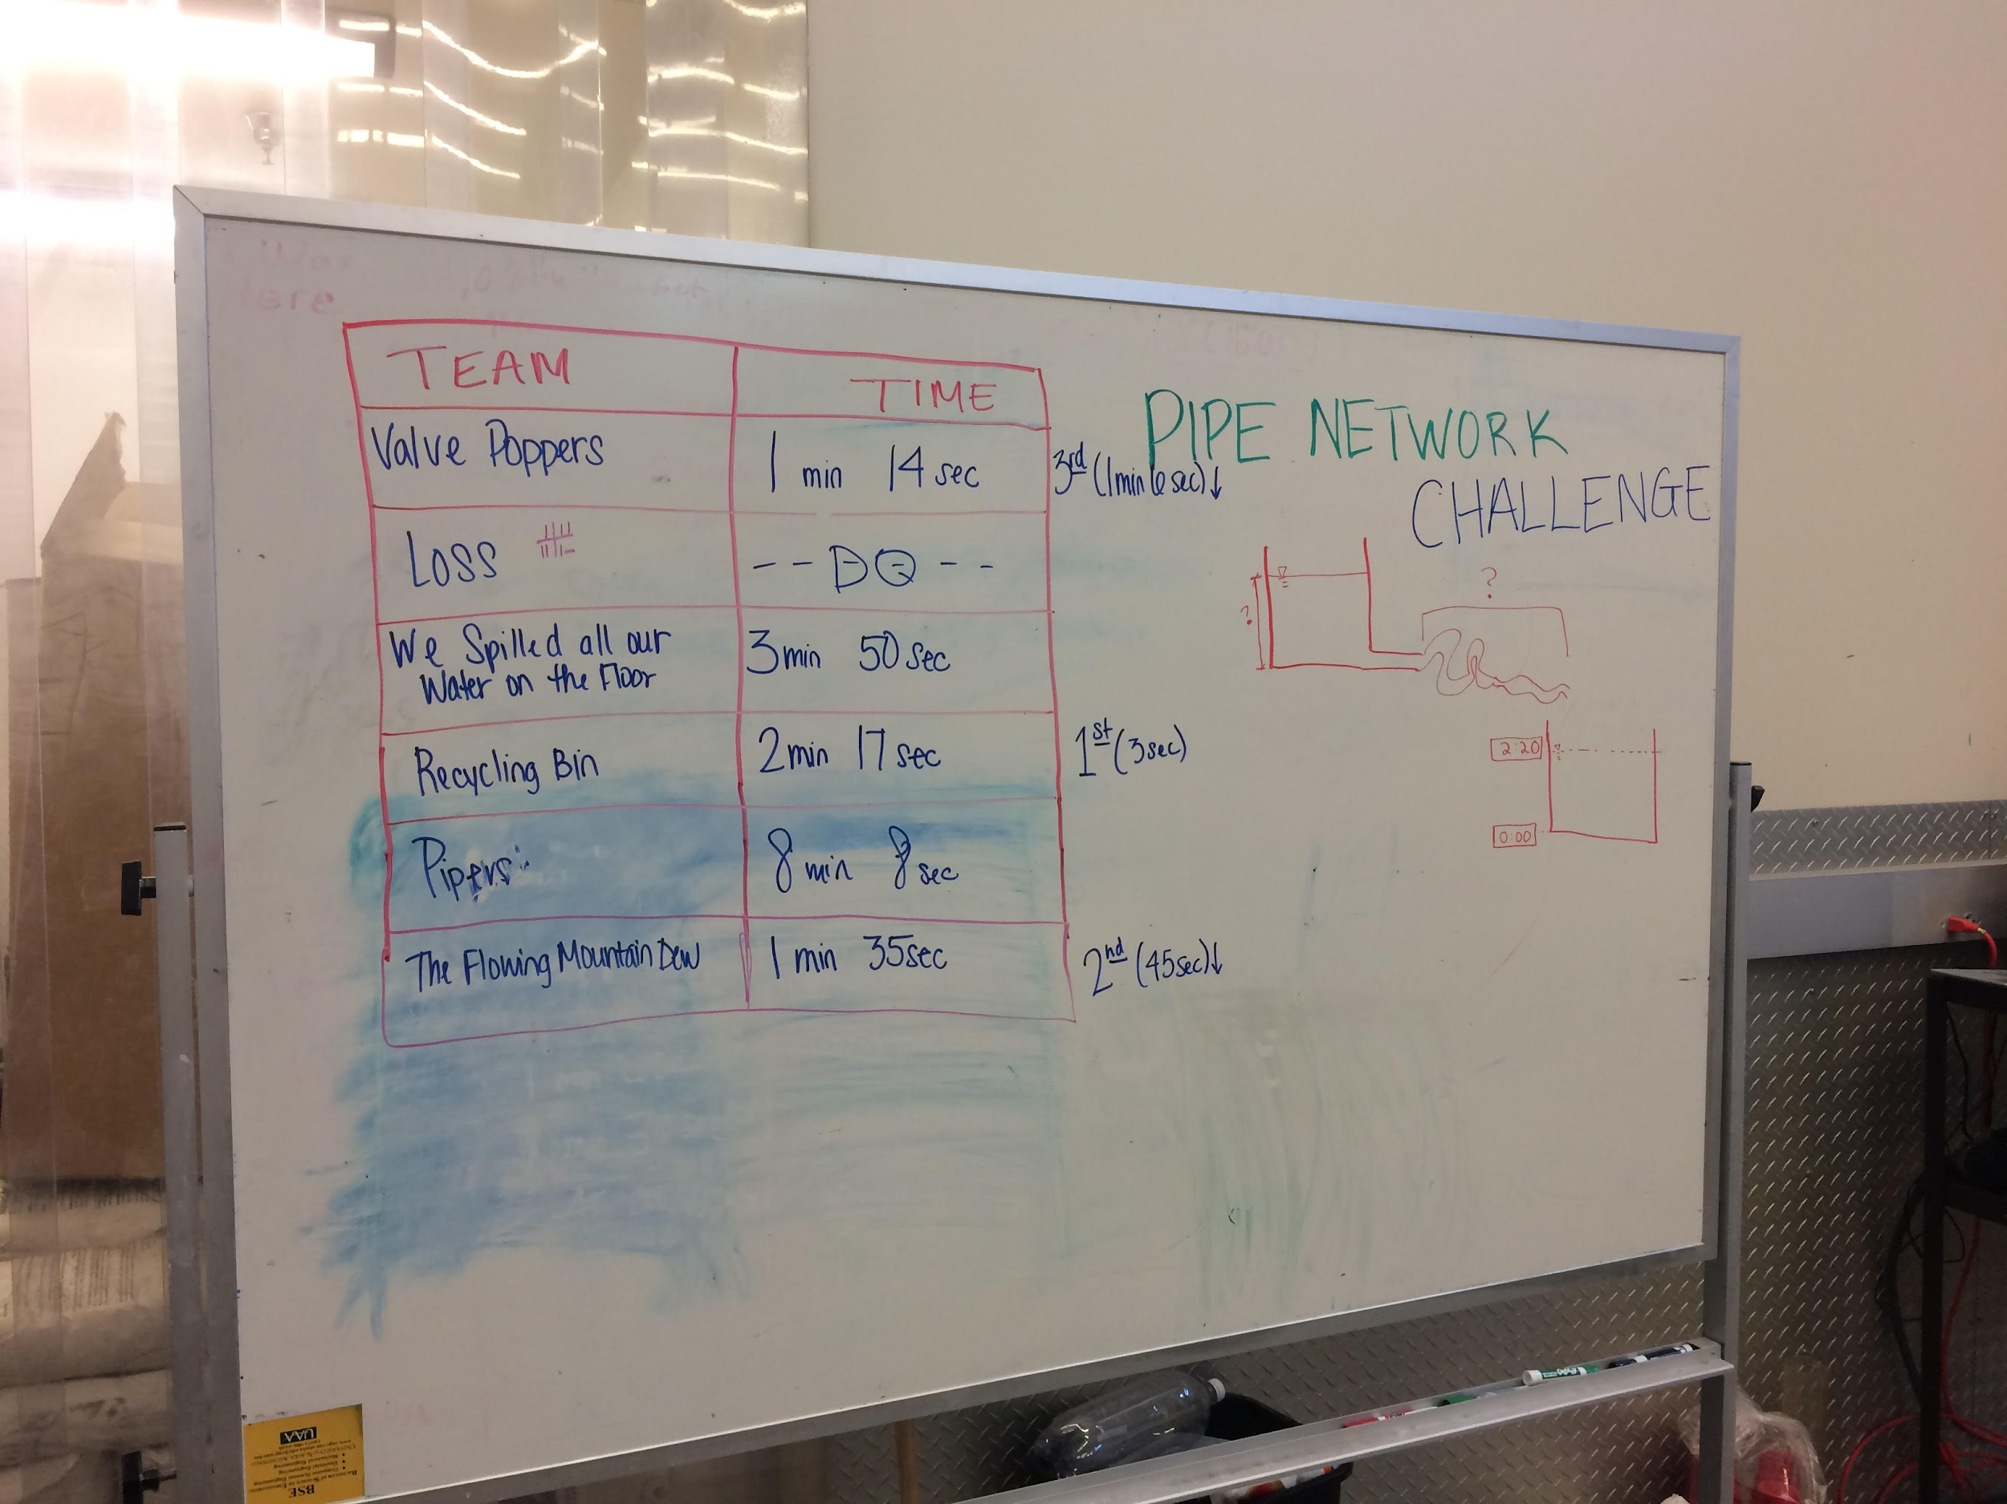
Practice: Allow students time to work in their groups to test with various trash cans and configurations.

Competition: During official rounds of competition, groups pre-fill their trash can and begin the timer as soon as the valve is opened. Every team records data on their competition log sheets along with observations about network design.

Discussion Questions: What was missing? What would have made it better? What about durability and long life? What about pressure? Which design performed best? Why do you think that was?

